Limerick Municipal Elections
1841-2009

Compiled By
John Cusack and Liam Hanley

Edited By
David Lee and Debbie Jacobs

Dedicated to the Memory
of
Denis M. Leonard
(1947-2009)

Acknowledgments

We wish to acknowledge the help and support of the following people and organisations without whose assistance this publication would not have been made possible:

Yvonne Boylan, Fingal Library; Sarah Cullinan, FÁS; Vera Cusack; Liam Dunne, Limerick County Library; Sean Gannon, Limerick City Library; Jacqui Hayes, Limerick City Archives; Brian Hodkinson, Limerick City Museum; Cllr Michael Hourigan; Michael McGuire, Limerick City Library; Jan O’Sullivan TD; Dr Matthew Potter; Frank Prendergast; Monica Spencer; Tony Storan, Limerick County Library.

The Staffs of: Clare County Library Local Studies Centre, Ennis; Cork City Library; Cork County Library; Fingal Library; Limerick City Library; Limerick County Library; National Library Dublin; Tallagh Library.

The researchers of Limerick Civic Trust History and Folklore Archives.

A special thank you to Dr James Ring, Manager of Limerick Civic Trust and the staff of Limerick Civic Trust.

A special recognition to Patrick J. Cusack who was a member of the Limerick City Council from 1925 to 1950.

Limerick Municipal Elections 1841-2009

Introduction

This publication lists the names of all those councillors elected to the Limerick City Council since 1841 when the electoral system for local government was first introduced to the city. This is the first time that such a list has ever been compiled and many thanks are due to John Cusack and Liam Hanley of the Limerick Civic Trust’s History Department for their untiring research work in gathering together the material.

Prior to their work interest in locally elected representatives was mainly focused on the city’s mayors and the names of many of the councillors who had not achieved this high office had fallen into oblivion. This was mainly due to the fact that Limerick Council had not kept records of their own elected members. Now their names can be permanently remembered and added to the roll of those who have served their city as public representatives.

The task in compiling such a list might at first sight seem a simple enough undertaking, but it did involve of lot of hard work searching through the archives, not only in Limerick but in Ennis, Cork and Dublin as well. Much painstaking effort was also expended on double-checking the spellings of names, party affiliations etc. because it was quickly established by the research team that typographical errors and misspellings did feature in the primary sources. Also, newspaper accounts of electoral results did not always accurately record the full list of successful candidates and a considerable amount of cross referencing had to take place.

The mission given to John Cusack and Liam Hanley was to record the names of all councillors elected to public office on Election Day and they have achieved this objective with flying colours. This listing does not take account of co-options on to the Council that took place between elections resulting from the death or resignation of councillors.

This publication is a very important contribution to local historical records and historians interested in studying the social and political life of Limerick since early Victorian times will find this roll call of elected councillors invaluable in tracing the development of local democracy in the city. It has a practical application in so very many ways. For instance, in conjunction with other primary sources such as trade directories, census returns, franchise qualifications etc., it will be a particularly useful tool in helping to draw up a picture of the social composition of the city’s local public representatives at any one point in time.

Many thanks have to be given to all those involved in this research project and for their fine contribution to the history of local democracy in Limerick.

David Lee
Debbie Jacobs
History and Folklore Department, Limerick Civic Trust
GLOSSARY

B: Builder
Cllr: Councillor
CnaG: Cumann na nGaedhael (Society of the Gaels)
CnaP: Clann na Poblachta
DSP: Democratic Socialist Party
FF: Fianna Fáil
FG: Fine Gael
GL: Gluais Linn
IND: Independent
INDL: Independent Labour
INDS: Independent Socialist
ITGWU: Irish Transport and General Workers Union
JP: Justice of the Peace
LAB: Labour Party
M: Merchant
MP: Member of Parliament
NP: Non Party
PRO: Progressive
PD: Progressive Democrats
PDEM: Peoples’ Democracy
RP: Ratepayer
REP: Republican
SF: Sinn Fein
TD: Teachta Dála, Member of Dáil
Sen: Member of Seanad Éireann
WP: Workers’ Party

Limerick Municipal Elections
1841-2009

From the year 1841 to 2009 there have been eighty-one municipal elections.

YEAR | NUMBER OF  WARDS | NUMBER OF COUNCIL SEATS
1841-1853 | 5 | 40
1854-1919 | 8 | 40
1920-1933 | 5 | 40
1934-1949 | 1 | 15
1950-1966 | 1 | 17
1967-2008 | 4 | 17
2009 | 3 | 17

 |  | Number of Councillors Elected
Number of Councils with 40 Seats | 67 | 2680
Number of Councils with 17 Seats | 11 | 187
Number of Councils with 15 Seats | 3 | 45

The total number of councillors elected is 2912 over the period 1841-2009. This figure does not take account of co-options or people voted on to the council between elections.
The election results of the eighty-one councils are the results on the day of the elections.

.

The Municipal Corporations (Ireland) Act 1840

On 10 August 1840 an Act for the regulation of municipal corporations in Ireland was passed and a year later on 10 August 1841 it became operational in Limerick. This bill followed the lines of the 1835 Act for England and Wales. Of the sixty-eight boroughs in Ireland, fifty-eight were dissolved and ten remained, one being Limerick Corporation. The old ‘Corrupt Corporations’ were stripped of their powers and municipal affairs were reformed, being transferred from small, self-elected cliques to councils of elected councillors more representative of citizens. The 1840 Act largely put an end to corruption, incompetence and dishonesty. More efficiency, effectiveness, accountability and economy were expected of the new corporations.

However, as a result of a technical breach of the 1840 Act, the mayor of the old Limerick corporation, Charles Smyth Vereker took legal action and refused to leave office resulting in there being two corporations operating in the city throughout the first half of 1842. The first real meeting of the new, reformed council took place on 3 August 1842 after the old Corrupt Corporation had finally bowed out under amended legislation enacted in July 1842.

The Municipal Corporations (Ireland) Act 1840 radically changed the constitution of the corporation. Limerick City was divided into five wards. The self-elected body of indefinite number was replaced with a council consisting of forty councillors (two candidates with the highest vote in each ward became aldermen) elected by the burgesses - all adult males who were in possession of property worth £10 or more per year. There was no general election of the council every few years. Instead, one third of the councillors went out of office annually and one half of the aldermen left office every three years. Those who left office were those who had held their position for the longest time without re-election. This meant that each councillor was elected for a three year period and each alderman for a six year period. Outgoing aldermen and councillors could stand for re-election. Men could not become a member of the City Council unless they possessed property worth £1,000 over and above debts or were in occupation of a house rated at £25 or more per year. If a man was bankrupt or was a clergyman or council official or had a business contract with the Corporation he was ineligible to be a councillor.

Besides Limerick Corporation another local government body was operating in the city until it was abolished in 1853. Known as the St Michael’s Commissioners, this body looked after the cleaning, paving, lighting and policing of Newtown Pery, the Georgian quarter of the city that had been developing on virgin land since the mid-eighteenth century. St Michael’s Commissioners had been established in 1807 to look after the prospering middle-class and business section of the city. The Commissioners were independent of the Corrupt Corporation that had been run by a self-perpetuating clique interested solely in its own enrichment at the expense of ordinary citizens.

The Reform Mayors

The strangest procession in Limerick’s history took place on August 10, 1841. To the funeral music of massed bands, a great concourse of mourners marched solemnly behind a hearse which contained an enormous coffin. When the huge throng of mourners reached the Town Hall the coffin was removed from the hearse and burned. Corporate reform had become an accomplished fact that day and the jubilant ‘mourners’ marked the death of municipal graft and corruption by consigning the ‘remains’ of the old Corporation to the purifying flames.

But if the old Corporation was dead, at least one member of it refused to lie down. The Hon. Charles Smyth Vereker, Mayor elected by the old Corporation, discovered a legal flaw in the operation of the Municipal Reform Act and he declared all the proceedings connected with the introduction of the Act null and void. The newly-constituted body had, in the meantime, elected Martin Honan Mayor on the 11th of November, and the citizens were posed with the amusing, if expensive, problem of paying homage to two masters. They quickly solved this, however, by refusing to pay tolls to either. This happy situation (which must be the fond reverie of many a member of our present Ratepayers’ Association) continued until July 1842 when Lord Elliot, the then Secretary for Ireland, got the Royal Assent to an Act legalizing the proceedings and settling the Corporation in office.

Martin Honan, the first of the Reform Mayors, initiated the practice of recording outstanding events on the Mayoral Chain.
Limerick Chronicle

From Limerick Souvenir Feile Padraig 1956

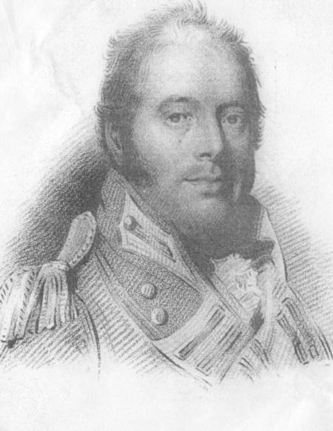

Charles Smyth Vereker
He controlled Limerick Corporation from 1817 to 1841.

Limerick Municipal Election Results
1841

John’s Street Ward

Aldermen: William J. Creagh; William J. Geary.
Councillors: James B. Boyd; John McDonnell; Charles O’Hara; Thomas Purcell;
Edward F. Ryan; William Sheehy.

Patrick Street Ward

Aldermen: Michael Dawson; Patrick O’Gorman.
Councillors: Edward Browne; John Cooke; Edward J. Corbett; Patrick Goulding;
Nicholas Kelly; James Morris.

Richmond Place Ward

Aldermen: Daniel Barrington; Michael Furnell.
Councillors: Edward Bernard; George Dartnell; Henry Maunsell; John N. Russell;
Thomas P. Vokes; Henry Watson.

Thomond Bridge Ward

Aldermen: Patrick Mulcahy; Pierce Shannon.
Councillors: Martin Honan; Richard Kane; Michael Kelly; Mathew Kenny;
Eugene O’Callaghan; Thomas Wallnutt.

William Street Ward

Aldermen: Richard Bodkin; John Boyse Sr.
Councillors: James Harvey; John McDonnell; John McNamara; Michael Quin;
Thomas Quin; Mathew B. Ryan.

* The date set for annual elections to replace outgoing councillors was 25
October or on the following day if this was a Sunday. In 1841 the population
of Limerick was 48.391, but the municipal electorate only numbered 1,227; of
these only 595 cast their vote in the first elections held in 1841. The council
elected the following year’s mayor on 1 November and he took up office on 1
January.
Limerick Municipal Election Results
1842

John’s Street Ward

Aldermen: William J. Creagh; William J. Geary.
Councillors: James B. Boyd; Stephen Drysdale; John McDonnell; Charles O’Hara;
Thomas Purcell; Edward F. Ryan.

Patrick Street Ward

Aldermen: Michael Dawson; Patrick O’Gorman.
Coouncillors: Edward Browne; John Cooke; Edward J. Corbett; Patrick Goulding;
Nicholas Kelly; Laurence Quinlivan.

Richmond Place Ward

Aldermen: Daniel Barrington; Michael Furnell.
Councillors: Edward Bernard; Thomas E. Carte; George Dartnell; Henry Maunsell;
Thomas P. Vokes; Henry Watson.

Thomond Bridge Ward

Aldermen: Patrick Mulcahy; Pierce Shannon.
Councillors: Martin Honan; Richard Kane; Michael Kelly; Mathew Kenny;
Eugene O’Callaghan; Thomas Wallnutt.

William Street Ward

Aldermen: Richard Bodkin; John Boyse Sr.
Councillors: James Harvey; John Hogan James; John McDonnell; Robert McMahon;
Michael Quin; Mathew B. Ryan.

Limerick Municipal Election Results
1843

John’s Gate Ward

Aldermen: William J. Geary; Edward F. Ryan.
Councillors: Joseph J. Bouchier; James B. Boyd; Stephen Drysdale; William Herbert;
John McDonnell; Thomas Purcell.

Patrick Street Ward

Aldermen: Michael Dawson; Patrick O’Gorman.
Councillors: Edward Browne; John Cooke; Patrick Goulding; Nicholas Kelly;
James Morris; Laurence Quinlivan.

Richmond Place Ward

Aldermen: Michael Furnell; Henry Watson.
Councillors: Edward Bernard; John Boyse Jr; Thomas E. Carte; William Griffin;
Thomas Kane; Henry Maunsell.

Thomond Bridge Ward

Aldermen: Patrick Mulcahy; Pierce Shannon.
Councillors: Martin Honan; Richard Kane, Michael Kelly; Mathew Kenny;
Eugene O’Callaghan; Thomas Wallnutt.

William Street Ward

Aldermen: Richard Bodkin; John Boyse Sr.
Councillors: James Harvey; John Hogan James; Robert McMahon; John McNamara;
Joseph Murphy; Michael Quin.

Limerick Municipal Councillors
1844

Aldermen present: Richard Bodkin, Mayor; John Boyse Sr; Michael Dawson;
Sir Richard Franklin; William J. Geary; Reuben Harvey;
Patrick Mulcahy; Patrick O’Gorman; Edward F. Ryan;
Henry Watson.

Councillors present: Edward Bernard; Joseph J. Bouchier; John Boyse Jr;
Edward Browne; John Carroll; Thomas E. Carte; John Cooke;
Stephen Creagh; Robert Fitzgerald; Robert Frost;
Dr William Griffin; William Herbert; Martin Honan;
John Hogan James; Capt. Richard Kane; Dr Thomas Kane;
Michael Kelly; Nicholas Kelly; Robert McMahon;
John McNamara; Joseph Murphy; Eugene O’Callaghan; Michael
O’Donovan; Michael Quin; Laurence Quinlivan; John Spillane;
Thomas Wallnutt.

* With no record available of the elections for the year 1844 the above list was
compiled with the aid of the Limerick Municipal Council minute book of 11
March 1845 and the Limerick Chronicle, 27 November 1844. Ten aldermen and
twenty-seven out of thirty councillors attended a meeting as recorded in the
minute book.

Limerick Municipal Election Results
1845

John’s Gate Ward

Aldermen: William J. Geary; Edward F. Ryan.
Councillors: Joseph J. Bouchier; James B. Boyd; John Carroll; Robert Frost;
Patrick Goulding; John McDonnell.

Patrick Street Ward

Aldermen: Michael Dawson; Patrick O’Gorman.
Councillors: Edward Browne; John Corbett; Robert Fitzgerald; Nicholas Kelly;
James Morris; Laurence Quinlivan.

Richmond Place Ward

Aldermen: Michael Furnell; Henry Watson.
Councillors: John Boyse Jr; Thomas E. Carte; William Griffin; Thomas Kane;
Robert McMahon; John W. Mahony.

Thomond Bridge Ward

Aldermen: Reuben Harvey; Patrick Mulcahy.
Councillors: Martin Honan; Richard Kane; James Kelly; Michael Kelly;
Eugene O’Callaghan; Thomas Wallnut.

William Street Ward

Aldermen: Richard Bodkin; John Boyse Sr.
Councillors: Stephen Creagh; James J. Kennedy; John McNamara; Joseph Murphy;
Michael Quin; John Spillane.

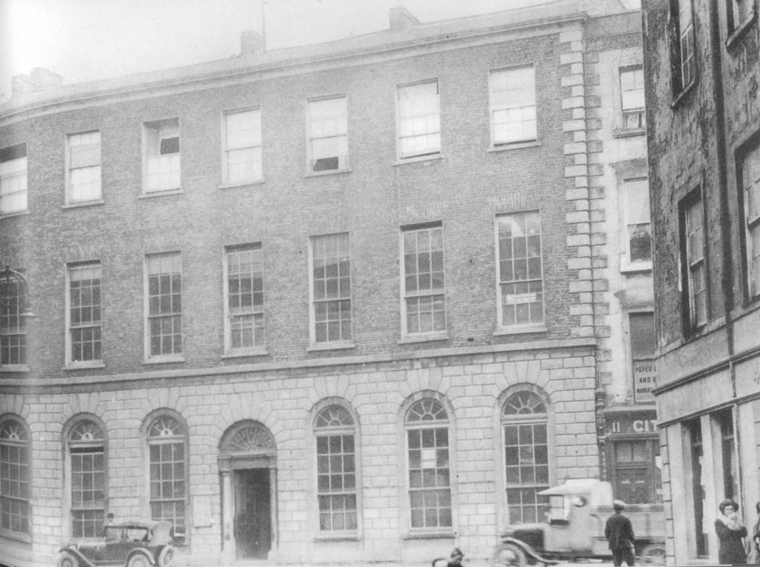

The Commercial Buildings on Rutland Street used as the Town Hall and headquarters of Limerick Corporation from 1846-1990.
(Courtesy of Limerick City Museum)

Limerick Municipal Election Results
1846

John’s Gate Ward

Aldermen: William J. Geary; Edward F. Ryan.
Councillors: Joseph J. Bouchier; James B. Boyd; John Carroll; Robert Frost;
Daniel McCarthy; John McDonnell.

Patrick Street Ward

Aldermen: Michael Dawson; Patrick O’Gorman.
Councillors: John Beveridge; John Corbett; John T. Devitt; John Egan;
Robert Fitzgerald; Laurence Quinlivan.

Richmond Place Ward

Aldermen: William H. Hall; Henry Watson.
Councillors: John Boyse Jr; Thomas E. Carte; William Gabbett; William Griffin;
Robert McMahon; John W. Mahony.

Thomond Bridge Ward

Aldermen: Reuben Harvey; Patrick Mulcahy.
Councillors: Daniel Cullen; Martin Honan; Richard Kane; Michael Kelly;
Pierce Shannon; Thomas Wallnutt.

William Street Ward

Aldermen: Richard Bodkin; John Boyse Sr.
Councillors: Stephen Creagh; James J. Kennedy; Joseph Murphy; William Purcell;
Michael Quin; John Spillane.

Limerick Municipal Election Results
1847

John’s Gate Ward

Aldermen: William J. Geary; William O’Hara.
Councillors: Joseph J. Bouchier; James B. Boyd; Robert Frost; Stephen Hastings;
Daniel McCarthy; John McDonnell.

Patrick Street Ward

Aldermen: Michael Dawson; Patrick O’Gorman.
Councillors: John Corbett; John T. Devitt; Patrick Lyddy; Charles McCarthy;
Laurence Quinlivan; James Ryan.

Richmond Place Ward

Aldermen: William H. Hall; Henry Watson.
Councillors: John Boyse Jr; Thomas E. Carte; William Gabbett; William R. Gore;
John W. Mahony; William Phayer.

Thomond Bridge Ward

Aldermen: Patrick Mulcahy; Thomas Wallnutt.
Councillors: Daniel Cullen; Martin Honan; Richard Kane; Thomas Kane;
Michael Kelly; Pierce Shannon.

William Street Ward

Aldermen: John Boyse Sr; Robert McMahon.
Councillors: William Glover; Michael McNamara; Bernard Mulrennen; William Purcell;
Michael Quin; Mathew B. Ryan.

Limerick Municipal Councillors
1848

Aldermen present: John Boyse Sr; Michael Dawson; William J. Geary;
William H. Hall; Robert McMahon; Patrick Mulcahy;
Patrick O’Gorman; William O’Hara; Thomas Wallnutt;
Henry Watson.

Councillors present: James B. Boyd; John Boyse Jr; Thomas E. Carte;
Edward Costelloe; Daniel Cullen; John Ellard; Robert Frost;
William Gabbett; David Garvey; John Gleeson; William R. Gore;
Stephen Hastings; William L. Joynt; Thomas Kane; Robert Keays;
Michael Kelly; Patrick Lyddy; Charles McCarthy;
John McDonnell; Michael McNamara; Bernard Mulrennan;
William O’Connell; Stephen O’Donnell; Mark T. O’Shaughnessy;
William Phayer; William Purcell; Michael Quin;
Laurence Quinlivan; Mathew B. Ryan; Pierce Shannon.

* With no record available of the elected aldermen and councilors for the year
1848 the above list was compiled with the aid of the Limerick Municipal
Council minute books of 1 December 1848, 1 January 1849 and 5 February 1849.
Limerick Municipal Election Results
1849

John’s Street Ward

Alderman: William J. Geary; William O’Hara.
Councillors: James B. Boyd; Robert Frost; Stephen Hastings; John McDonnell;
Edmond O’Connell; William O’Connell.

Patrick Street Ward

Aldermen: Michael Dawson; Patrick O’Gorman.
Councillors: John Ellard; Patrick Lyddy; Charles McCarthy; James McCarthy;
Mark T. O’Shaughnessy; Laurence Quinlivan.

Richmond Place Ward

Aldermen: William H. Hall; Henry Watson.
Councillors: John Barrington; Thomas E. Carte; William Gabbett; William R. Gore;
Robert Keays; William Phayer.

Thomond Bridge Ward

Aldermen: Patrick Mulcahy; Pierce Shannon.
Councillors: Edward Costelloe; Daniel Cullen; John Gleeson; William L. Joynt;
Thomas Kane; Michael Kelly.

William Street Ward

Aldermen: Thomas McDonnell; Robert McMahon.
Councillors: Patrick Lynch; Michael McNamara; Bernard Mulrennan;
Stephen O’Donnell; Michael Quin; Mathew B. Ryan.

Limerick Municipal Election Results
1850

John’s Street Ward

Aldermen: William J. Geary; John McDonnell.
Councillors: James B. Boyd; Robert Frost; Stephen Hastings; Edmond O’Connell;
William O’Connell; James Quin.

Patrick Street Ward

Aldermen: Michael Dawson; Patrick O’Gorman.
Councillors: John Ellard; Patrick Lyddy; James McCarthy; James Morris;
Mark T. O’Shaughnessy; Laurence Quinlivan.

Richmond Place Ward

Aldermen: William H. Hall; Henry Watson.
Councillors: John Barrington; Stanley Bourchier; Thomas E. Carte; William Gabbett;
Robert Keays; William Phayer.

Thomond Bridge Ward

Aldermen: Patrick Mulcahy; Pierce Shannon.
Councillors: Daniel Cullen; William Delany; John Gleeson; William L. Joynt;
Thomas Kane; Michael Kelly.

William Street Ward

Aldermen: Thomas McDonnell; Robert McMahon.
Councillors: Joseph B. Kennedy; Patrick Lynch; John O’Donnell; Stephen O’Donnell;
Michael Quin; Mathew B. Ryan.

Limerick Municipal Elections Results
1851

John’s Street Ward

Aldermen: William J. Geary; John McDonnell.
Councillors: Robert Frost; Stephen Hastings; Edmond O’Connell; William O’Connell;
Sarsfield Pillon; James Quin.

Patrick Street Ward

Aldermen: Michael Dawson; Patrick O’Gorman.
Councillors: John Ellard; Patrick Lyddy; James Morris; Mark T. O’Shaughnessy;
Laurence Quinlivan; William Tubbs.

Richmond Place Ward

Aldermen: William H. Hall; Henry Watson.
Councillors: John Barrington; Stanley Bourchier; Thomas E. Carte; William Gabbett;
Robert Keays; William Phayer.

Thomond Bridge Ward

Aldermen: Patrick Mulcahy; Pierce Shannon.
Councillors: Daniel Cullen; William Delany; John Gleeson; William L. Joynt;
Thomas Kane; Michael Kelly.

William Street Ward

Aldermen: Thomas McDonnell; Robert McMahon.
Councillors: Joseph B. Kennedy; Patrick Lynch; John O’Donnell; Michael Quin;
John T. Sheehy; John F. Walker.

Limerick Municipal Election Results
1852

John’s Street Ward

Aldermen: Stephen Hastings; John McDonnell.
Councillors: Joseph Bowles; Robert Frost; Edmond O’Connell; William O’Connell;
John S. Pillon; James Quin.

Patrick Street Ward

Aldermen: Michael Dawson; Laurence Quinlivan.
Councillors: Thomas Boyse; Daniel Doyle; John Ellard; Maurice Lenihan;
James Morris; Andrew Tracy.

Richmond Place Ward

Aldermen: William H. Hall; Henry Watson.
Councillors: John Barrington; Stanley Bourchier; Thomas E. Carte; William Gabbett;
Robert Keays; William Phayer.

Thomond Bridge Ward

Aldermen: Patrick Mulcahy; Pierce Shannon.
Councillors: Daniel Cullen; William Delany; John Gleeson; William L. Joynt;
Thomas Kane; Michael Kelly.

William Street Ward

Aldermen: Thomas McDonnell; Robert McMahon.
Councillors: Joseph B. Kennedy; Patrick Lynch; John O’Donnell; Michael Quin;
John T. Sheehy; John F. Walker.

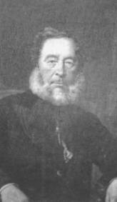

Maurice Lenihan
Member of Limerick City Council from 1853-1863 and 1868-1887.
(Courtesy of Limerick City Archives)

Limerick Corporation Act 1853

On 28 June 1853 the Limerick Corporation Act became law. Limerick City was divided into eight electoral wards replacing the previous five. There were still forty councillors in total but each ward returned five councillors as opposed to eight previously. There was only one alderman per ward where previously there had been two. One quarter of the councillors went out of office every year and half of the aldermen left office every third year. The term of office for a councillor increased from three to four years while that of an alderman remained at six years. Annual elections to the council were held on 25 November and the Mayor elected on 1 December (taking office on 1 January).

Limerick Improvement Act 1853

The inadequacies of the Municipal Corporations Act 1840 required that further legislation in the early 1850s was needed to remedy problems which had incurred. On the 15 August 1853 the Limerick Improvement Act 1853 was enacted. Both the St Michael’s Parish Commissioners and the Grand Jury were abolished making the Corporation the sole local authority for the city. The Poor Law Union continued to operate though, providing Limerick City with its public health and social welfare system up to 1923. The cleansing of public streets, drainage, lighting, paving, sewerage and general improvements were now the responsibility of the Corporation as well as providing, and funding, infrastructure. The building of a cemetery and establishment of a police force were among other powers Limerick Corporation was granted.

Limerick Municipal Election Results
1853

Abbey Ward
Alderman: William L. Joynt.
Councillors: Edmond Gabbett; John Gleeson; Eugene O’Callaghan; Pierce Shannon.

Castle Ward

Alderman: Patrick Mulcahy.
Councillors: Daniel Cullen; Daniel Doyle; Thomas Kane; Arthur Russell.

Custom House Ward
Alderman: Laurence Quinlivan.
Councillors: Thomas Boyse; Michael Dawson; Maurice Lenihan; William Spaight.

Dock Ward
Alderman: Richard Russell.
Councillors: John Barrington; William H. Hall; Robert Keays; Francis Ward.

Glentworth Ward
Alderman: Henry Watson.
Councillors: Stanley Bourchier; Thomas E. Carte; Michael Gavin; William Phayer.

Irishtown Ward
Alderman: Edmond O’Connell.
Councillors: William G. Gubbins; Stephen Hastings; John McDonnell; James Quin.

Market Ward
Alderman: John R. Tinsley
Councillors: John O’Donnell; John S. Pillon; Michael Quin; John T. Sheehy.

Shannon Ward
Alderman: Thaddeus McDonnell.
Councillors: Edward J. Corbett; William O’Hara; Henry O’Shea; Francis Spaight.

Limerick Municipal Election Results
1854

Abbey Ward
Alderman: William L. Joynt.
Councillors: Edmond Gabbett; John Gleeson; Eugene O’Callaghan; Pierce Shannon.

Castle Ward
Alderman: Patrick Mulcahy.
Councillors: Daniel Cullen; Thomas Kane; Michael Kelly; Arthur Russell.

Custom House Ward
Alderman: Laurence Quinlivan.
Councillors: Thomas Boyse; Michael Dawson; Maurice Lenihan; William Spaight.

Dock Ward
Alderman: Richard Russell.
Councillors: John Barrington; Robert Keays; James Spaight; Francis Ward.

Glentworth Ward
Alderman: Henry Watson.
Councillors: Stanley Bourchier; Thomas E. Carte; Patrick Lynch; William Phayer.

Irishtown Ward

Alderman: Edmond O’Connell.
Councillors: William G. Gubbins; Stephen Hastings; John McDonnell; William Sheehy,

Market Ward
Alderman: John R. Tinsley.
Councillors: John Barry; Robert McMahon; Michael Quin; John T. Sheehy.

Shannon Ward
Alderman: Thaddeus McDonnell.
Councillors: Edward J. Corbett; William O’Hara; Henry O’Shea; Francis Spaight.

Limerick Municipal Election Results
1855

Abbey Ward
Alderman: William L. Joynt.
Councillors: John T. Devitt; Edmond Gabbett; Eugene O’Callaghan; Pierce Shannon.

Castle Ward
Alderman: Patrick Mulcahy.
Councillors: Daniel Cullen; Thomas Kane; Michael Kelly; Arthur Russell.

Custom House Ward
Alderman: Laurence Quinlivan.
Councillors: Thomas Boyse; Michael Dawson; Maurice Lenihan; William Spaight.

Dock Ward
Alderman: Richard Russell.
Councillors: Robert Keays; Robert Rodger; James Spaight; Francis Ward.

Glentworth Ward
Alderman: Henry Watson.
Councillors: Stanley Bourchier; Thomas E. Carte; Patrick Lynch; William Phayer.

Irishtown Ward
Alderman: Edmond O’Connell.
Councillors: David Garvey; Stephen Hastings; John McDonnell; William Sheehy.

Market Ward
Alderman: John R. Tinsley.
Councillors: John Barry; Robert McMahon; Michael Quin; John T. Sheehy.

Shannon Ward
Alderman: Thaddeus McDonnell.
Councillors: Edward J. Corbett; William O’Hara; Henry O’Shea; Francis Spaight.

Limerick Municipal Election Results
1856

Abbey Ward
Alderman: William L. Joynt.
Councillors: John T. Devitt; John Fitzgerald; Edmond Gabbett; Eugene O’Callaghan.

Castle Ward
Alderman: Patrick Mulcahy.
Councillors: Daniel Cullen; Thomas Kane; Michael Kelly; Arthur Russell.

Custom House Ward
Alderman: Laurence Quinlivan.
Councillors: Thomas Boyse; Michael Dawson; Maurice Lenihan; William Spaight.

Dock Ward
Alderman: William Fitzgerald.
Councillors: Robert Keays; Robert Rodger; James Spaight; Francis Ward.

Glentworth Ward
Alderman: Henry Watson.
Councillors: Stanley Bourchier; Thomas E. Carte; Patrick Lynch; William Phayer.

Irishtown Ward
Alderman: Edmond O’Connell.
Councillors: David Garvey; Stephen Hastings; John McDonnell; William Sheehy.

Market Ward
Alderman: John R. Tinsley.
Councillors: John Barry; Robert McMahon; John T. Sheehy; William Purcell.

Shannon Ward
Alderman: Thaddeus McDonnell.
Councillors: William O’Hara; Henry O’Shea; Michael R. Ryan; Francis Spaight.

Limerick Municipal Election Results
1857

Abbey Ward
Alderman: William L. Joynt.
Councillors: John T. Devitt; John Fitzgerald; Edmond Gabbett; Eugene O’Callaghan.

Castle Ward
Alderman: Patrick Mulcahy.
Councillors: Daniel Cullen; Thomas Kane; Michael Kelly; Arthur Russell.

Custom House Ward
Alderman: Laurence Quinlivan.
Councillors: Thomas Boyse; Laurence Kelly; Maurice Lenihan; William Spaight.

Dock Ward
Alderman: William Fitzgerald.
Councillors: Robert Keays; Robert Rodger; James Spaight; Francis Ward.

Glentworth Ward
Alderman: Henry Watson.
Councillors: John Barrington; Stanley Bourchier; Thomas E. Carte; William Phayer.

Irishtown Ward
Alderman: Edmond O’Connell.
Councillors: David Garvey; Stephen Hastings; John McDonnell; William Sheehy.

Market Ward
Alderman: John R. Tinsley.
Councillors: John Barry; Robert McMahon; John T. Sheehy; William Purcell.

Shannon Ward
Alderman: Thaddeus McDonnell.
Councillors: John Ellard; William O’Hara; Michael R. Ryan; Francis Spaight.

Limerick Municipal Election Results
1858

Abbey Ward
Alderman: William L. Joynt.
Councillors: John T. Devitt; John Fitzgerald; Edmond Gabbett; Eugene O’Callaghan.

Castle Ward
Alderman: Patrick Mulcahy.
Councillors: Daniel Cullen; Thomas Kane; Michael Kelly; Arthur Russell.

Custom House Ward
Alderman: Laurence Quinlivan.
Councillors: Thomas Boyse; Laurence Kelly; Maurice Lenihan; William Spaight.

Dock Ward
Alderman: William Fitzgerald.
Councillors: Robert Keays; Robert Rodger; James Spaight MP; Francis Ward.

Glentworth Ward
Alderman: Henry Watson.
Councillors: John Barrington; Stanley Bourchier; Thomas E. Carte; William Phayer.

Irishtown Ward
Alderman: William Sheehy.
Councillors: David Garvey; William G. Gubbins; Stephen Hastings; John McDonnell.

Market Ward
Alderman: John R. Tinsley.
Councillors: John Barry; Robert McMahon; John T. Sheehy; William Purcell.

Shannon Ward
Alderman: Thaddeus McDonnell.
Councillors: Zachary Myles; John O’Donnell; Michael R. Ryan; Francis Spaight.

Limerick Municipal Election Results
1859

Abbey Ward
Alderman: William L. Joynt.
Councillors: John T. Devitt; John Fitzgerald; Edmond Gabbett; Eugene O’Callaghan.

Castle Ward
Alderman: Patrick Mulcahy.
Councillors: Daniel Cullen; Thomas Kane; Michael Kelly; Arthur Russell.

Custom House Ward
Alderman: Laurence Quinlivan.
Councillors: Thomas Boyse; Laurence Kelly; Maurice Lenihan; William Spaight.

Dock Ward
Alderman: William Fitzgerald.
Councillors: Robert Keays; Robert Rodger; James Spaight; Francis Ward.

Glentworth Ward
Alderman: Henry Watson.
Councillors: John Barrington; John Bassett; Thomas E. Carte; William Phayer.

Irishtown Ward
Alderman: William Sheehy.
Councillors: David Garvey; William G. Gubbins; Stephen Hastings; John McDonnell.

Market Ward
Alderman: John R. Tinsley.
Councillors: John Barry; Robert McMahon; John T. Sheehy; William Purcell.

Shannon Ward
Alderman: Thaddeus McDonnell.
Councillors: Zachary Myles; John O’Donnell; Michael R. Ryan; Francis Spaight.

Limerick Municipal Election Results
1860

Abbey Ward
Alderman: William L. Joynt.
Councillors: John T. Devitt; Edmond Gabbett; Robert McDonnell; Eugene O’Callaghan.

Castle Ward
Alderman: Patrick Mulcahy.
Councillors: Daniel Cullen; Thomas Kane; Michael Kelly; Arthur Russell.

Custom House Ward
Alderman: Laurence Quinlivan.
Councillors: Thomas Boyse; Laurence Kelly; Maurice Lenihan; William Spaight.

Dock Ward
Alderman: John W. Mahony.
Councillors: Robert Keays; Robert Rodger; James Spaight; Francis Ward.

Glentworth Ward
Alderman: Thomas E. Carte.
Councillors: John Barrington; John Bassett; Patrick Lynch; William Phayer.

Irishtown Ward
Alderman: James Quin.
Councillors: David Garvey; William G. Gubbins; Stephen Hastings; John McDonnell.

Market Ward
Alderman: John R. Tinsley.
Councillors: John Barry; Robert McMahon; John T. Sheehy; William Purcell.

Shannon Ward
Alderman: Thaddeus McDonnell.
Councillors: Zachary Myles; John O’Donnell; Michael R. Ryan; Francis Spaight.

Limerick Municipal Election Results
1861

Abbey Ward
Alderman: William L. Joynt.
Councillors: William Delany; Edmond Gabbett; Robert McDonnell;
Eugene O’Callaghan.

Castle Ward
Alderman: Patrick Mulcahy.
Councillors: Daniel Cullen; Thomas Kane; Michael Kelly; Arthur Russell.

Custom House Ward
Alderman: Laurence Quinlivan.
Councillors: Thomas Boyse; Laurence Kelly; Maurice Lenihan; William Spaight.

Dock Ward
Alderman: John W. Mahony.
Councillors: Robert Keays; Robert Rodger; James Spaight; Francis Ward.

Glentworth Ward
Alderman: Thomas E. Carte.
Councillors: John Barrington; Gerald Fitzgerald; Patrick Lynch; William Phayer.

Irishtown Ward
Alderman: James Quin.
Councillors: David Garvey; William G. Gubbins; Stephen Hastings; John McDonnell.

Market Ward
Alderman: John R. Tinsley.
Councillors: John Barry; Robert McMahon; John T. Sheehy; William Purcell.

Shannon Ward
Alderman: Thaddeus McDonnell.
Councillors: Ambrose (Amby) Hall; Zachary Myles; John O’Donnell; Michael R. Ryan.

Limerick Municipal Election Results
1862

Abbey Ward
Alderman: William L. Joynt.
Councillors: William Delany; Edmond Gabbett; Robert McDonnell;
Eugene O’Callaghan.

Castle Ward
Alderman: Patrick Mulcahy.
Councillors: Daniel Cullen; Thomas Kane; Michael Kelly; Arthur Russell.

Custom House Ward
Alderman: Laurence Quinlivan.
Councillors: Thomas Boyce; James Hickey; Laurence Kelly; Maurice Lenihan.

Dock Ward
Alderman: John W. Mahony.
Councillors: Robert Keays; Robert Rodger; James Spaight; Francis Ward.

Glentworth Ward
Alderman: Thomas E. Carte.
Councillors: John Barrington; Gerald Fitzgerald; Patrick Lynch; William Phayer.

Irishtown Ward
Alderman: James Quin.
Councillors: David Garvey; Stephen Hastings; John McDonnell; Patrick Synan.

Market Ward
Alderman: John R. Tinsley.
Councillors: John Barry; Robert McMahon; John T. Sheehy; William Purcell.

Shannon Ward
Alderman: Thaddeus McDonnell.
Councillors: Ambrose (Amby) Hall; Zachary Myles; John O’Donnell; Michael R. Ryan.

Limerick Municipal Election Results
1863

Abbey Ward
Alderman: William L. Joynt.
Councillors: William Delany; Edmond Gabbett JP; Robert McDonnell;
Eugene O’Callaghan JP.

Castle Ward
Alderman: Patrick Mulcahy.
Councillors: Daniel Cullen; Thomas Kane JP; Michael Kelly; Arthur Russell.

Custom House Ward
Alderman: Laurence Quinlivan JP.
Councillors: Thomas Boyse JP; Henry J. Hall; James Hickey; Laurence Kelly.

Dock Ward
Alderman: John W. Mahony JP.
Councillors: Robert Keays; Robert Rodger JP; James Spaight JP; Francis Ward.

Glentworth Ward
Alderman: Thomas E. Carte.
Councillors: John Barrington; Gerald Fitzgerald; Patrick Lynch; William Phayer JP.

Irishtown Ward
Alderman: James Quin.
Councillors: David Garvey; Stephen Hastings; John McDonnell JP; Patrick Synan.

Market Ward
Alderman: John R. Tinsley JP.
Councillors: John Barry; Robert McMahon JP; John T. Sheehy JP; William Purcell.

Shannon Ward
Alderman: Thaddeus McDonnell JP.
Councillors: Ambrose (Amby) Hall; Zachary Myles; John O’Donnell;
Michael R. Ryan JP.

Limerick Municipal Election Results
1864

Abbey Ward
Alderman: Patrick Hogan.
Councillors: Eugene O’Callaghan JP; Robert McDonnell; William Delany;
Edmond Gabbett JP.

Castle Ward
Alderman: Daniel Cullen.
Councillors: Thomas Kane JP; Michael Kelly; Michael Mulcahy; Arthur Russell.

Custom House Ward
Alderman: Laurence Quinlivan.
Councillors: Thomas Boyse JP; John H. Hall; James Hickey; Laurence Kelly.

Dock Ward
Alderman: John W. Mahony JP.
Councillors: Joseph Parker; Robert Rodger JP; James Spaight JP; Francis Ward.

Glentworth Ward
Alderman: Thomas E. Carte.
Councillors: John Barrington; Gerald Fitzgerald; Patrick Lynch; William Phayer JP.

Irishtown Ward
Alderman: James Quin.
Councillors: David Garvey; Stephen Hastings; John McDonnell JP; Patrick Synan.

Market Ward
Alderman: John R. Tinsley JP.
Councillors: John Barry; Robert McMahon JP; John T. Sheehy; William Purcell.

Shannon Ward
Alderman: Thaddeus McDonnell JP.
Councillors: Ambrose (Amby) Hall; Zachary Myles; John O’Donnell. Michael R. Ryan.

* It was reported in the Limerick Chronicle, Tuesday 7 February 1865 that at a
Town Council meeting Peter Tait had been duly elected alderman for the
Castle Ward to replace Alderman Daniel Cullen deceased.
Limerick Municipal Election Results
1865

Abbey Ward
Alderman: Patrick Hogan.
Councillors: William Delany; Robert McDonnell; Denis McNamara;
Eugene O’Callaghan JP.

Castle Ward
Alderman: Peter Tait.
Councillors: Thomas Kane JP; Laurence Kelly; Michael Kelly; Arthur Russell.

Custom House Ward
Alderman: Laurence Quinlivan JP.
Councillors: Thomas Boyse JP; John H. Hall; James Hickey; John Quin.

Dock Ward
Alderman: John W. Mahony JP.
Councillors: Joseph Parker; Robert Rodger; James Spaight JP; Francis Ward.

Glentworth Ward
Alderman: Thomas E. Carte.
Councillors: John Barrington; James Harris; Patrick Lynch; William Phayer JP.

Irishtown Ward
Alderman: James Quin.
Councillors: Richard Gamble; David Garvey, Stephen Hastings; Patrick Synan.

Market Ward
Alderman: John R. Tinsley JP.
Councillors: John Barry; Robert McMahon JP; John T. Sheehy JP; William Purcell.

Shannon Ward
Alderman: Thaddeus McDonnell JP.
Councillors: Ambrose (Amby) Hall; Zachary Myles; John O’Donnell;
Michael R. Ryan JP.

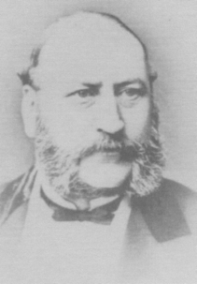

Peter Tait
Member of Limerick City Council from 1865-1868
(Courtesy of Limerick City Council)

Limerick Municipal Election Results
1866

Abbey Ward
Alderman: Patrick Hogan.
Councillors: William Delany; Robert McDonnell; Denis McNamara;
Eugene O’Callaghan JP.

Castle Ward
Alderman: Peter Tait.
Councillors: Thomas Kane JP; Laurence Kelly; Michael Kelly; Arthur Russell.

Custom House Ward
Alderman: Laurence Quinlivan.
Councillors: Thomas Boyse JP; John H. Hall; James Hickey; John Quin.

Dock Ward
Alderman: John W. Mahony JP.
Councillors: Joseph Parker; Robert Rodger JP; James Spaight JP; Francis Ward.

Glentworth Ward
Alderman: Thomas E. Carte.
Councillors: John Barrington; James Harris; Patrick Lynch; William Phayer JP.

Irishtown Ward
Alderman: James Quin.
Councillors: Richard Gamble; David Garvey; Stephen Hastings; Patrick Synan.

Market Ward
Alderman: John R. Tinsley.
Councillors: John Barry; Robert McMahon JP; John T. Sheehy JP; William Purcell.

Shannon Ward
Alderman: Thaddeus McDonnell JP.
Councillors: Ambrose (Amby) Hall; Zachary Myles; John O’Donnell; Michael R. Ryan.

Limerick Municipal Election Results
1867

Abbey Ward
Alderman: Patrick Hogan.
Councillors: William Delany; John Hayes; Robert McDonnell; Denis McNamara.

Castle Ward
Alderman: Peter Tait.
Councillors: Thomas Kane JP; Laurence Kelly; Michael Kelly; Michael Mulcahy.

Custom House Ward
Alderman: Laurence Quinlivan JP.
Councillors: Thomas Boyse JP; John H. Hall; James Hickey; John Quin.

Dock Ward
Alderman: John W. Mahony JP.
Councillors: Joseph Parker; Robert Rodger JP; James Spaight JP; Francis Ward.

Glentworth Ward
Alderman: Thomas E. Carte.
Councillors: John Barrington; James Harris; Robert McMahon JP; William Phayer JP.

Irishtown Ward
Alderman: James Quin.
Councillors: Richard Gamble; David Garvey; Stephen Hastings; Patrick Synan.

Market Ward
Alderman: John R. Tinsley JP.
Councillors: John Barry; John Cronin; Daniel O’Connor; William Spillane.

Shannon Ward
Alderman: Thaddeus McDonnell JP.
Councillors: Ambrose (Amby) Hall; Zachary Myles; John O’Donnell;
Michael R. Ryan JP.

Limerick Municipal Election Results
1868

Abbey Ward
Alderman: Patrick Hogan.
Councillors: William Delany; John Hayes; Robert McDonnell; Denis McNamara.

Castle Ward
Alderman: Eugene O’Callaghan JP.
Councillors: Thomas Kane JP; Laurence Kelly; Michael Kelly; Michael Mulcahy.

Custom House Ward

Alderman: Laurence Quinlivan JP.
Councillors: Thomas Boyse JP; James Hickey; Maurice Lenihan; John Quin.

Dock Ward
Alderman: John W. Mahony JP.
Councillors: Joseph Parker; Robert Rodger JP; James Spaight JP; Francis Ward.

Glentworth Ward
Alderman: Thomas E. Carte.
Councillors: John Barrington; James Harris; Robert McMahon JP; William Phayer JP.

Irishtown Ward
Alderman: James Quin.
Councillors: Richard Gamble; David Garvey; Stephen Hastings; Patrick Synan.

Market Ward
Alderman: John R. Tinsley JP.
Councillors: John Barry; John Cronin; Daniel O’Connor; William Spillane.

Shannon Ward
Alderman: Thaddeus McDonnell JP.
Councillors: Ambrose (Amby) Hall; Zachary Myles; John O’Donnell;
Michael R. Ryan JP.

Limerick Municipal Election Results
1869

Abbey Ward
Alderman: Patrick Hogan.
Councillors: William Delany; John Hayes; Robert McDonnell; Denis McNamara.

Castle Ward
Alderman: Eugene O’Callaghan JP.
Councillors: Thomas Kane JP; Laurence Kelly; Michael Kelly; Michael Mulcahy.

Custom House Ward
Alderman: Laurence Quinlivan JP.
Councillors: Thomas Boyse JP; James Hickey; Maurice Lenihan; John Quin.

Dock Ward
Alderman: John W. Mahony JP.
Councillors: Gerald Fitzgerald; Joseph Parker; James Spaight JP; Francis Ward.

Glentworth Ward
Alderman: Thomas E. Carte.
Councillors: John Barrington; John J. Cleary; Robert McMahon JP; William Phayer JP.

Irishtown Ward
Alderman: James Quin.
Councillors: David Garvey; Stephen Hastings; Richard Raleigh; Patrick Synan.

Market Ward
Alderman: John R. Tinsley JP.
Councillors: John Barry; John Cronin; Daniel O’Connor; William Spillane.

Shannon Ward
Alderman: Thaddeus McDonnell.
Councillors: Patrick S. Connolly; Ambrose (Amby) Hall; Zachary Myles;
Michael R. Ryan.

Limerick Municipal Election Results
1870

Abbey Ward
Alderman: Patrick Hogan.
Councillors: William Delany; John Hayes; Robert McDonnell; Denis McNamara.

Castle Ward
Alderman: Eugene O’Callaghan JP.
Councillors: Thomas Kane JP; Laurence Kelly; Michael Kelly; Michael Mulcahy.

Custom House Ward
Alderman: Laurence Quinlivan JP.
Councillors: Thomas Boyse JP; James Hickey; Maurice Lenihan; John Quin.

Dock Ward
Alderman: John W. Mahony JP.
Councillors: Gerald Fitzgerald; Joseph Parker; James Spaight JP; Francis Ward.

Glentworth Ward
Alderman: Thomas E. Carte.
Councillors: John Barrington; John J. Cleary; Robert McMahon JP; William Phayer JP.

Irishtown Ward
Alderman: James Quin.
Councillors: David Garvey; Stephen Hastings; Richard Raleigh; Patrick Synan.

Market Ward
Alderman: John R. Tinsley JP.
Councillors: John Barry; John Cronin; Daniel O’Connor; William Spillane.

Shannon Ward
Alderman: Thaddeus McDonnell.
Councillors: Patrick S. Connolly; Ambrose (Amby) Hall; Zachary Myles;
Michael R. Ryan.

Limerick Municipal Election Results
1871

Abbey Ward
Alderman: Patrick Hogan.
Councillors: William Delany; John Hayes; Robert McDonnell; Denis McNamara.

Castle Ward
Alderman: Eugene O’Callaghan JP.
Councillors: Thomas Kane JP; Laurence Kelly; Michael Kelly; John F.Walker.

Custom House Ward
Alderman: Laurence Quinlivan JP.
Councillors: Jerome Counihan; Maurice Lenihan JP; Michael O’Gorman; John Quin.

Dock Ward
Alderman: John W. Mahony.
Councillors: John Abraham; Gerald Fitzgerald; Joseph Parker; James Spaight JP.

Glentworth Ward
Alderman: Thomas E. Carte.
Councillors: John Barrington; John J. Cleary JP; Thomas McMahon Cregan;
William Phayer JP.

Irishtown Ward
Alderman: James Quin.
Councillors: Michael Garvey; Stephen Hastings; Michael Ryan; Patrick Synan.

Market Ward
Alderman: John R. Tinsley JP.
Councillors: John Barry; John Cronin; Daniel O’Connor; William Spillane JP.

Shannon Ward
Alderman: Thaddeus McDonnell JP.
Councillors: Patrick S. Connolly; Ambrose (Amby) Hall; Zachary Myles;
Michael R. Ryan JP.

Limerick Municipal Election Results
1872

Abbey Ward
Alderman: Patrick Hogan.
Councillors: William Delany; John Hayes; Robert McDonnell; Denis McNamara.

Castle Ward
Alderman: Eugene O’Callaghan.
Councillors: Laurence Kelly; Michael Kelly; James Nash; John F. Walker.

Custom House Ward
Alderman: Laurence Quinlivan.
Councillors: Jerome Counihan; Maurice Lenihan JP; Michael O’Gorman; John Quin.

Dock Ward
Alderman: John Abraham.
Councillors: John Bernal; Daniel Doyle; Joseph Parker; James Spaight JP.

Glenthworth Ward
Alderman: Thomas E. Carte.
Councillors: John Barrington; John J. Cleary; Thomas McMahon Cregan;
William Phayer JP.

Irishtown Ward
Alderman: James Quin.
Councillors: John J. Browne; Stephen Hastings; Michael Ryan; Patrick Synan.

Market Ward
Alderman: John R. Tinsley JP.
Councillors: John Barry; John Cronin; Daniel O’Connor; William Spillane JP.

Shannon Ward
Alderman: Patrick S. Connolly.
Councillors: Ambrose (Amby) Hall; William Hosford; Zachary Myles;
Michael R. Ryan JP.

* In 1872 Prime Minister William Gladstone introduced the Secret Ballot Act 1872
for all parliamentary and municipal elections. The British law was designed to
protect voters from bribery and coercion. The secret ballot was also called the
‘Australian ballot’ because it was first used in Australian elections in 1856.

Limerick Municipal Election Results
1873

Abbey Ward
Alderman: Patrick Hogan.
Councillors: William Delany; John Hayes; Robert McDonnell; Denis McNamara.

Castle Ward
Alderman: Eugene O’Callaghan JP.
Councillors: Laurence Kelly; Michael Kelly; James Nash; John F. Walker.

Custom House Ward
Alderman: Laurence Quinlivan JP.
Councillors: Jerome Counihan; Maurice Lenihan JP; Michael O’Gorman; John Quin.

Dock Ward
Alderman: John Abraham.
Councillors: John Bernal; Joseph Parker; James Spaight JP; Alfred C. Wallace.

Glentworth Ward
Alderman: Thomas E. Carte.
Councillors: John J. Cleary; Thomas McMahon Cregan; Thomas G. O’Sullivan;
William Phayer JP.

Irishtown Ward
Alderman: Patrick Synan.
Councillors: John J. Browne; Stephen Hastings; John F. Moloney; Michael Ryan.

Market Ward
Alderman: John R. Tinsley JP.
Councillors: John Barry; John Cronin; Daniel O’Connor; William Spillane JP.

Shannon Ward
Alderman: Zachary Myles.
Councillors: Ambrose (Amby) Hall; William Hosford; Donot C. O’Brien;
Michael R. Ryan JP.

Limerick Municipal Election Results
1874

Abbey Ward
Alderman: Patrick Hogan.
Councillors: William Delany; John Hayes; Robert McDonnell; Denis McNamara.

Castle Ward
Alderman: Eugene O’Callaghan.
Councillors: George W. Bassett; Laurence Kelly; James Nash; John F. Walker.

Custom House Ward
Alderman: Laurence Quinlivan.
Councillors: Jerome Counihan; Maurice Lenihan; Michael O’Gorman; John Quin.

Dock Ward
Alderman: John Abraham.
Councillors: John Bernal; Thomas G. O’Sullivan; Richard Phillips; James Spaight.

Glentworth Ward
Alderman: Thomas E. Carte.
Councillors: John J. Cleary; Thomas McMahon Cregan; William Phayer;
Alfred C. Wallace.

Irishtown Ward
Alderman: Patrick Synan.
Councillors: John J. Browne; Stephen Hastings; John F. Moloney; Michael Ryan.

Market Ward
Alderman: John R. Tinsley.
Councillors: John Barry; John Cronin; Daniel O’Connor; William Spillane.

Shannon Ward
Alderman: Zachary Myles.
Councillors: Ambrose (Amby) Hall; John Hardiman; William Hosford;
Donat C. O’Brien.

Limerick Municipal Election Results
1875

Abbey Ward
Alderman: Patrick Hogan.
Councillors: William Delany; John Hayes; Robert McDonnell; Denis McNamara.

Castle Ward
Alderman: Eugene O’Callaghan JP.
Councillors: George W. Bassett; Laurence Kelly; James Nash; John F. Walker.

Custom House Ward
Alderman: Laurence Quinlivan JP.
Councillors: Jerome Counihan; Maurice Lenihan; Michael O’Gorman; John Quin.

Dock Ward
Alderman: John Abraham.
Councillors: John Bernal; Thomas G. O’Sullivan; Richard Phillips; James Spaight JP.

Glentworth Ward
Alderman: John J. Cleary.
Councillors: James J. Browne; Thomas McMahon Cregan; William Phayer JP;
Alfred C. Wallace.

Irishtown Ward
Alderman: Patrick Synan.
Councillors: Stephen Hastings; John F. Moloney; George Russell; Michael Ryan.

Market Ward
Alderman: John R. Tinsley JP.
Councillors: John Barry; John Cronin; Daniel O’Connor; Patrick Riordan.

Shannon Ward
Alderman: Zachary Myles.
Councillors: Ambrose (Amby) Hall; John Hardiman; William Hosford;
Donat C. O’Brien.

Limerick Municipal Election Results
1876

Abbey Ward
Alderman: Patrick Hogan.
Councillors: William Delany; John Hayes; Robert McDonnell; Denis McNamara.

Castle Ward
Alderman: Eugene O’Callaghan.
Councillors: George W. Bassett; Laurence Kelly; James Nash; John F. Walker.

Custom House Ward
Alderman: John Quin.
Councillors: Jerome Counihan; Maurice Lenihan JP; John Neiland; Michael O’Gorman.

Dock Ward
Alderman: John Abraham.
Councillors: John Bernal; Richard Phillips; James Spaight JP; Thomas G. O’Sullivan.

Glentworth Ward
Alderman: John J. Cleary.
Councillors: James J. Browne; Thomas McMahon Cregan; William Phayer JP;
Alfred C. Wallace.

Irishtown Ward
Alderman: Patrick Synan.
Councillors: Eugene Coomey; John F. Moloney; Stephen O’Flanagan; Michael Ryan.

Market Ward
Alderman: John R. Tinsley JP.
Councillors: John Barry; John Cronin; Daniel O’Connor; Patrick Riordan.

Shannon Ward
Alderman: Zachary Myles.
Councillors: John Hardiman; Stephen Hastings; William Hosford; Donat C. O’Brien.

Limerick Municipal Election Results
1877

Abbey Ward
Alderman: Patrick Hogan.
Councillors: William Delany; John Hayes; Robert McDonnell; Denis McNamara.

Castle Ward
Alderman: Eugene O’Callaghan JP.
Councillors: George W. Bassett; Laurence Kelly; James Nash; John F. Walker.

Custom House Ward
Alderman: John Quin.
Councillors: Jerome Counihan; Maurice Lenihan JP; Martin McGuire;
Michael O’Gorman

Dock Ward
Alderman: Richard Phillips JP.
Councillors: John Bernal; Charles McDonnell; Thomas G. O’Sullivan;
James Spaight JP.

Glentworth Ward
Alderman: John J. Cleary.
Councillors: James J. Browne; Thomas McMahon Cregan; William Phayer JP;
Alfred C. Wallace.

Irishtown Ward
Alderman: Patrick Synan.
Councillors: Eugene Coomey; John F. Moloney; Stephen O’Flanagan; Michael Ryan.

Market Ward
Alderman: John R. Tinsley JP.
Councillors: John Barry; John Cronin; Daniel O’Connor; Patrick Riordan.

Shannon Ward
Alderman: Zachary Myles.
Councillors: John Hardiman; Stephen Hastings; William Hosford; Donat C. O’Brien.

Limerick Municipal Election Results
1878

Abbey Ward
Alderman: Patrick Hogan.
Councillors: William Delany; John Hayes; Robert McDonnell; Denis McNamara.

Castle Ward
Alderman: Eugene O’Callaghan.
Councillors: George W. Bassett; Laurence Kelly; James Nash; John F. Walker.

Custom House Ward
Alderman: John Quin.
Councillors: Jerome Counihan; Maurice Lenihan JP; Martin McGuire;
Michael O’Gorman.

Dock Ward
Alderman: Richard Phillips.
Councillors: John Bernal; Charles McDonnell; Thomas G. O’Sullivan;
James Spaight JP.

Glentworth Ward
Alderman: John J. Cleary.
Councillors: James J. Browne; Thomas McMahon Cregan; William Phayer JP;
Alfred C. Wallace.

Irishtown Ward
Alderman: Patrick Synan.
Councillors: Eugene Coomey; John F. Moloney; James Nolan; Stephen O’ Flanagan.

Market Ward
Alderman: John R. Tinsley JP.
Councillors: John Cronin; Joseph P. McNamara; Daniel O’Connor; Patrick Riordan.

Shannon Ward
Alderman: Zachary Myles.
Councillors: John Hardiman; Stephen Hastings; William Hosford; Daniel Synan.

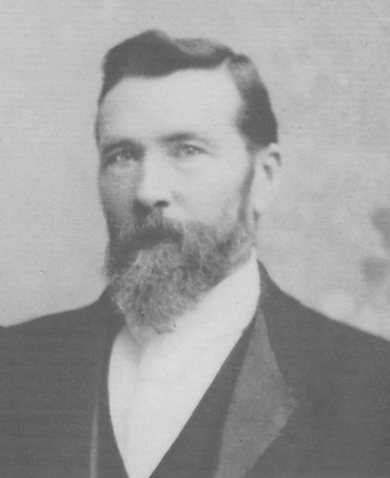

Stephen O’Mara
Member of Limerick City Council from 1879-1908
(Courtesy of Limerick City Archives)

Limerick Municipal Election Results
1879

Abbey Ward
Alderman: Patrick Hogan.
Councillors: William Delany; John Hayes; Robert McDonnell; Denis McNamara.

Castle Ward
Alderman: Eugene O’Callaghan.
Councillors: George W. Bassett; Laurence Kelly; James Nash; John F. Walker.

Custom House Ward
Alderman: John Quin.
Councillors: Jerome Counihan; Maurice Lenihan; Martin McGuire; Michael O’Gorman.

Dock Ward
Alderman: Richard Phillips.
Councillors: John Bernal; Charles McDonnell; Thomas G. O’Sullivan;
James Spaight JP.

Glentworth Ward
Alderman: John J. Cleary JP.
Councillors: James Browne; Ambrose (Amby) Hall; William Hosford;
Alfred C. Wallace.

Irishtown Ward
Alderman: Patrick Synan.
Councillors: Eugene Coomey; John F. Moloney; James Nolan; Stephen O’Flanagan.

Market Ward
Alderman: John R. Tinsley JP.
Councillors: John Cronin; Joseph P. McNamara; Daniel O’Connor; Patrick Riordan.

Shannon Ward
Alderman: Zachary Myles.
Councillors: John Hardiman; Stephen Hastings; Stephen O’Mara; Daniel Synan.

Limerick Municipal Election Results
1880

Abbey Ward
Alderman: Patrick Hogan.
Councillors: William Delany; John Hayes; Robert McDonnell; Denis F. McNamara.

Castle Ward
Alderman: Eugene O’Callaghan JP.
Councillors: George W. Bassett; William Boyd JP; Laurence Kelly; John F. Walker.

Custom House Ward
Alderman: John Quin.
Councillors: Jerome Counihan; Maurice Lenihan JP; Martin McGuire;
Michael O’Gorman J.P.

Dock Ward
Alderman: Richard Phillips.
Councillors: John Bernal; Charles McDonnell; Thomas G. O’Sullivan;
James Spaight JP;

Glentworth Ward
Alderman: John J. Cleary JP.
Councillors: James J. Browne; Ambrose (Amby) Hall; William Hosford;
Alfred C. Wallace.

Irishtown Ward
Alderman: Patrick Synan.
Councillors: John F. Moloney; James Nolan; Stephen O’Flanagan; John Ryan.

Market Ward
Alderman: John Cronin.
Councillors: Jeremiah Anglim; Joseph P. McNamara; Daniel O’Connor;
Patrick Riordan.

Shannon Ward
Alderman: Zachary Myles.
Councillors: Stephen Hastings; Bryan O’Donnell; Stephen O’Mara; Daniel Synan.

Limerick Municipal Election Results
1881

Abbey Ward
Alderman: Patrick Hogan.
Councillors: John Hayes; Robert McDonnell; Denis F. McNamara; Laurence O’Keefe.

Castle Ward
Alderman: John F. Walker.
Councillors: George W. Bassett; William Boyd JP; J. Hennessy;
Laurence Kelly.

Custom House Ward
Alderman: John Quin.
Councillors: Jerome Counihan JP; Maurice Lenihan JP; Michael O’Brien;
Michael O’Gorman.

Dock Ward
Alderman: Richard Phillips JP.
Councillors: John Bernal; Charles McDonnell; Thomas G. O’Sullivan;
James Spaight JP.

Glentworth Ward
Alderman: John J. Cleary JP.
Councillors: James J. Browne; Ambrose (Amby) Hall; William Hosford;
Alfred C. Wallace.

Irishtown Ward
Alderman: Patrick Synan.
Councillors: John F. Moloney; James Nolan; Stephen O’Flanagan; John Ryan.

Market Ward
Alderman: John Cronin.
Councillors: Jeremiah Anglim; Joseph P. McNamara; Daniel O’Connor;
Patrick Riordan.

Shannon Ward
Alderman: Zachary Myles.
Councillors: Stephen Hastings; Bryan O’Donnell; Stephen O’Mara; Daniel Synan.

Limerick Municipal Election Results
1882

Abbey Ward
Alderman: Patrick Hogan.
Councillors: John Hayes; Robert McDonnell; Denis F. McNamara; Laurence O’Keeffe.

Castle Ward
Alderman: John F. Walker.
Councillors: William Boyd; J. Hennessy; Laurence Kelly; Stephen McSwiney.

Custom House Ward
Alderman: John Quin.
Councillors: Jerome Counihan; Maurice Lenihan JP; Michael O’Brien;
Michael O’Gorman.

Dock Ward
Alderman: Richard Phillips JP.
Councillors: John Bernal; Thomas Gaffney; Charles McDonnell; Thomas G. O’Sullivan.

Glentworth Ward
Alderman: John J. Cleary JP.
Councillors: James J. Browne; John Dundon; Ambrose (Amby) Hall; William Hosford.

Irishtown Ward
Alderman: Patrick Synan.
Councillors: John F. Moloney; James Nolan; Stephen O’Flanagan; John Ryan.

Market Ward
Alderman: John Cronin.
Councillors: Jeremiah Anglim; Joseph P. McNamara; Daniel O’Connor;
Patrick Riordan.

Shannon Ward
Alderman: Zachary Myles.
Councillors: Stephen Hastings; Bryan O’Donnell; Stephen O’Mara; Daniel Synan.

Limerick Municipal Election Results
1883

Abbey Ward
Alderman: Patrick Hogan.
Councillors: John Hayes; Robert McDonnell; Denis F. McNamara; Laurence O’Keeffe.

Castle Ward
Alderman: John F. Walker.
Councillors: William Boyd JP; Laurence Kelly; Patrick McSweeney;
Stephen McSwiney.

Custom House Ward
Alderman: Jerome Counihan.
Councillors: Michael G. Dowling; Maurice Lenihan JP; Michael O’Brien;
Michael O’Gorman.

Dock Ward
Alderman: Richard Phillips JP.
Councillors: John Bernal; Thomas Gaffney; Charles McDonnell; Thomas G. O’Sullivan.

Glentworth Ward
Alderman: John J. Cleary JP.
Councillors: James J. Browne; John Dundon; Ambrose (Amby) Hall; William Hosford.

Irishtown Ward
Alderman: Daniel Ryan.
Councillors: Michael Kennelly; James Nolan; Stephen O’Flanagan; John Ryan.

Market Ward
Alderman: John Cronin.
Councillors: Jeremiah Anglim; Joseph P. McNamara; Daniel O’Connor;
Patrick Riordan.

Shannon Ward
Alderman: Zachary Myles.
Councillors: Stephen Hastings JP; Bryan O’Donnell; Stephen O’Mara; Daniel Synan.

Limerick Municipal Elections
1884

Abbey Ward
Alderman: David Landers.
Councillors: John Hayes; Robert McDonnell; Denis F. McNamara; Laurence O’Keeffe.

Castle Ward
Alderman: John F. Walker.
Councillors: William Boyd JP; Laurence Kelly; Patrick McSweeney;
Stephen McSwiney.

Custom House Ward
Alderman: Jerome Counihan.
Councillors: Michael G. Dowling; Maurice Lenihan JP; Michael O’Brien;
Michael O’Gorman.

Dock Ward
Alderman: Richard Phillips.
Councillors: John Bernal; Thomas McMahon Cregan; Thomas Gaffney; John F. Power.

Glentworth Ward
Alderman: John J. Cleary JP.
Councillors: James J.Browne; John Dundon; Ambrose (Amby) Hall JP;
Edward H. O’Callaghan.

Irishtown Ward
Alderman: Daniel Ryan.
Councillors: James Nolan; Stephen O’Flanagan; John Ryan; John Synan.

Market Ward
Alderman: John Cronin.
Councillors: Jeremiah Anglim; Daniel O’Connor; Patrick Riordan; Michael Spain.

Shannon Ward
Alderman: Zachary Myles.
Councillors: Stephen Hastings JP; Bryan O’Donnell; Stephen O’Mara; Daniel Synan.

Limerick Municipal Election Results
1885

Abbey Ward
Alderman: David Landers.
Councillors: John Hayes; Robert McDonnell JP; Denis F. McNamara;
Laurence O’Keeffe.

Castle Ward
Alderman: John F. Walker.
Councillors: William Boyd JP; Laurence Kelly; Patrick McSweeney;
Stephen McSwiney.

Custom House Ward
Alderman: Jerome Counihan JP.
Councillors: Michael G. Dowling; Maurice Lenihan JP; Michael O’Gorman;
Francis A. O’Keeffe.

Dock Ward
Alderman: Richard Phillips JP.
Councillors: John Bernal; Thomas McMahon Cregan JP; Thomas Gaffney JP;
John F. Power.

Glentworth Ward
Alderman: John J. Cleary.
Councillors: James Browne; John Dundon; Ambrose (Amby) Hall JP;
Edward H. O’Callaghan.

Irishtown Ward
Alderman: Daniel Ryan.
Councillors: Michael Donnelly; Daniel Kennelly; Stephen O’Flanagan; John Ryan.

Market Ward
Alderman: John Cronin.
Councillors: Jeremiah Anglim; John Clune; Stephen F.Dowling JP; Patrick Riordan.

Shannon Ward
Alderman: Zachary Myles JP.
Councillors: David Begley; Stephen O’Mara; Laurence E. Ryan; Michael Spain.

Limerick Municipal Election Results
1886

Abbey Ward
Alderman: David Landers.
Councillors: John Hayes; Robert McDonnell JP; Denis F. McNamara;
Laurence O’Keeffe.

Castle Ward
Alderman: John F. Walker.
Councillors: William Boyd JP; Thomas Hartigan; Laurence Kelly; Patrick McSweeney.

Custom House Ward
Alderman: Jerome Counihan JP.
Councillors: Michael G. Dowling; Maurice Lenihan JP; Stephen McSwiney;
Francis A. O’Keeffe.

Dock Ward
Alderman: Richard Phillips JP.
Councillors: John Bernal; Thomas McMahon Cregan JP; Thomas Gaffney JP;
John F. Power.

Glentworth Ward
Alderman: John Dundon.
Councillors: James Browne; Ambrose (Amby) Hall JP; Edward H. O’Callaghan;
Michael R. O’Connor.

Irishtown Ward
Alderman: Daniel Ryan.
Councillors: Michael Donnelly; Daniel Kennelly; Stephen O’Flanagan; John Ryan.

Market Ward
Alderman: Patrick Riordan.
Councillors: Jeremiah Anglim; John Clune; Stephen F. Dowling JP; Patrick Herbert.

Shannon Ward
Alderman: Zachary Myles JP.
Councillors: David Begley; Stephen O’Mara; Laurence E. Ryan; Michael Spain.

Limerick Municipal Election Results
1887

Abbey Ward
Alderman: David Landers.
Councillors: John Hayes; Robert McDonnell JP; Denis F. McNamara;
Laurence O’Keeffe.

Castle Ward
Alderman: John F. Walker.
Councillors: William Boyd JP; Thomas Hartigan; Patrick McSweeney;
William J. O’Donnell.

Custom House Ward
Alderman: Jerome Counihan JP.
Councillors: Michael G. Dowling; Jeremiah McCarthy; Stephen McSwiney;
Francis A. O’Keeffe.

Dock Ward
Alderman: Richard Phillips JP.
Councillors: John Bernal; Thomas Gaffney; Charles McDonnell; Thomas G. O’Sullivan.

Glentworth Ward
Alderman: John J. Cleary JP.
Councillors: James Browne; John Dundon; Ambrose (Amby) Hall; William Hosford.

Irishtown Ward
Alderman: Daniel Ryan.
Councillors: Michael Donnelly; Daniel Kennelly; Stephen O’Flanagan; John Ryan.

Market Ward
Alderman: Patrick Riordan.
Councillors: Jeremiah Anglim; John Clune; Stephen F. Dowling JP; Patrick Herbert.

Shannon Ward
Alderman: Zachary Myles.
Councillors: Stephen Hastings; Bryan O’Donnell; Stephen O’Mara; Daniel Synan.

Limerick Municipal Election Results
1888

Abbey Ward
Alderman: David Landers.
Councillors: John Hayes; Robert McDonnell JP; Denis F. McNamara;
Laurence O’Keeffe.

Castle Ward
Alderman: John F. Walker.
Councillors: Thomas Hartigan; Patrick McSweeney; William J. O’Donnell;
Laurence E. Ryan.

Custom House Ward
Alderman: Jerome Counihan JP.
Councillors: Michael G. Dowling; Jeremiah McCarthy; Stephen McSwiney;
Francis A. O’Keeffe.

Dock Ward
Alderman: Thomas Gaffney JP.
Councillors: John Bernal; Thomas McMahon Cregan JP; James O’Mara; John F. Power.

Glentworth Ward
Alderman: John Dundon.
Councillors: Michael Cusack; Maurice Hennessy; Patrick Kenna; Michael R. O’Connor.

Irishtown Ward
Alderman: Daniel Ryan.
Councillors: Michael Donnelly; Daniel Kennelly; Stephen O’Flanagan; John Ryan.

Market Ward
Alderman: Patrick Riordan.
Councillors: Jeremiah Anglim; John Clune; Stephen F. Dowling JP; Patrick O’Meally.

Shannon Ward
Alderman: Zachary Myles JP.
Councillors: David Begley; Bryan O’Donnell; Stephen O’Mara; Michael Spain.

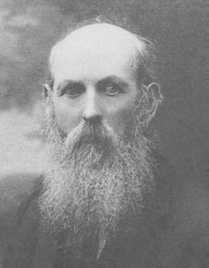

John Daly
Member of Limerick City Council from 1899-1906
(Courtesy of Limerick City Museum)

Limerick Municipal Election Results
1889

Abbey Ward
Alderman: David Landers.
Councillors: John Hayes; John P. Kearney; Robert McDonnell; Denis F. McNamara.

Castle Ward
Alderman: John F. Walker.
Councillors: Thomas Hartigan; Patrick McSweeney; William J. O’Donnell;
Laurence E. Ryan.

Custom House Ward
Alderman: Jerome Counihan JP.
Councillors: Michael G. Dowling; Jeremiah McCarthy; Stephen McSwiney;
Francis A. O’Keeffe

Dock Ward
Alderman: Thomas Gaffney JP.
Councillors: John Bernal; Thomas McMahon Cregan JP; James O’Mara; John F. Power.

Glentworth Ward
Alderman: John Dundon.
Councillors: Michael Cusack; Mauice Hennessy; Patrick Kenna; Michael R. O’Connor.

Irishtown Ward
Alderman: Daniel Ryan.
Councillors: Michael Donnelly; Daniel Kennelly; Stephen O’Flanagan; John Ryan.

Market Ward
Alderman: Patrick Riordan.
Councillors: Jeremiah Anglim; John Clune; Stephen F. Dowling; Patrick O’Meally.

Shannon Ward
Alderman: Stephen O’Mara.
Councillors: David Begley; Patrick Herbert; Bryan O’Donnell; Michael Spain.

Limerick Municipal Election Results
November 1890

Abbey Ward
Alderman: David Landers.
Councillors: John Hayes; John P. Kearney; Robert McDonnell JP;
Denis F. McNamara.

Castle Ward
Alderman: John F. Walker.
Councillors: Thomas Hartigan; Patrick McSweeney; William J. O’Donnell;
Laurence E. Ryan.

Custom House Ward
Alderman: Jerome Counihan JP.
Councillors: Michael G. Dowling; Jeremiah McCarthy; James H. Moran;
Francis A. O’Keeffe MP.

Dock Ward
Alderman: Thomas Gaffney JP.
Councillors: John Bernal; Thomas McMahon Cregan JP; James O’Mara; John F. Power.

Glentworth Ward
Alderman: John Dundon.
Councillors: William E. Counihan; Michael Cusack; Maurice Hennessy; Patrick Kenna.

Irishtown Ward
Alderman: Daniel Ryan.
Councillors: Michael Donnelly; Daniel Kennelly; Stephen O’Flanagan; John Ryan.

Market Ward
Alderman: Patrick Riordan.
Councillors: Jeremiah Anglim; John Clune; Stephen F. Dowling; Patrick O’Meally.

Shannon Ward
Alderman: Stephen O’Mara.
Councillors: David Begley; Patrick Herbert; Bryan O’Donnell; Michael Spain.

Limerick Municipal Election Results
1891

Abbey Ward
Alderman: David Landers.
Councillors: John Hayes; John P. Kearney; Robert McDonnell JP; Denis F. McNamara.

Castle Ward
Alderman: John F. Walker.
Councillors: Thomas Donnellan; Thomas Hartigan; William M. John;
William J. O’Donnell.

Custom House Ward
Alderman: Jerome Counihan MP.
Councillors: Michael G. Dowling; Jeremiah McCarthy; James H. Moran;
Francis A. O’Keeffe JP.

Dock Ward
Alderman: Thomas Gaffney JP.
Councillors: John Bernal; Patrick E. Bourke; Thomas McMahon Cregan JP;
James O’Mara.

Glentworth Ward
Alderman: John Dundon.
Councillors: William E. Counihan; Michael Cusack; Maurice Hennessy; Patrick Kenna.

Irishtown Ward
Alderman: Daniel Ryan.
Councillors: Michael Donnelly; Patrick Franklin; Daniel Kennelly; Stephen O’Flanagan.

Market Ward
Alderman: Patrick Riordan.
Councillors: Jeremiah Anglim; John Clune; Stephen F. Dowling; Patrick O’Meally.

Shannon Ward
Alderman: Stephen O’Mara.
Councillors: David Begley; Patrick Herbert; Bryan O’Donnell; Michael Spain.

Limerick Municipal Election Results
1892

Abbey Ward
Alderman: David Landers.
Councillors: John Hayes; John Kinahan; Michael McDonnell; Denis F. McNamara.

Castle Ward
Alderman: Ambrose (Amby) Hall JP.
Councillors: Thomas Donnellan; Thomas Hartigan; William J. O’Donnell;
Richard Smith.

Custom House Ward
Alderman: Jerome Counihan JP.
Councillors: Stephen Hastings; Jeremiah McCarthy; John McMahon;
Francis A. O’Keeffe MP.

Dock Ward
Alderman: Thomas Gaffney.
Councillors: John Bernal; Patrick E. Bourke; Thomas McMahon Cregan JP;
James O’Mara.

Glentworth Ward
Alderman: John Dundon.
Councillors: William E. Counihan; Michael Cusack; Maurice Hennessy; Patrick Kenna.

Irishtown Ward
Alderman: Daniel Ryan.
Councillors: Michael Donnelly; Patrick Franklin; Daniel Kennelly; Stephen O’Flanagan.

Market Ward
Alderman: Patrick Riordan.
Councillors: Jeremiah Anglim; John Clune; Stephen F. Dowling JP; William Nolan.

Shannon Ward
Alderman: Stephen O’Mara.
Councillors: David Begley; Patrick Herbert; Bryan O’Donnell; Michael Spain.

Limerick Municipal Election Results
November 1893

Abbey Ward
Alderman: David Landers.
Councillors: John Hayes; John Kinahan; Michael McDonnell; Denis F. McNamara.

Castle Ward

Alderman: Ambrose (Amby) Hall JP.
Councillors: William Bassett; Thomas Donnellan; Thomas Hartigan; Richard Smith.

Custom House Ward
Alderman: Jerome Counihan JP.
Councillors: Stephen Hastings; Jeremiah McCarthy; John McMahon;
Francis A. O’Keeffe MP.

Dock Ward
Alderman: Thomas Gaffney JP.
Councillors: John Bernal; Patrick E. Bourke JP; Thomas McMahon Cregan JP;
James O’Mara JP.

Glentworth Ward
Alderman: John Dundon.
Councillors: William E. Counihan; Michael Cusack; Maurice Hennessy; Patrick Kenna.

Irishtown Ward
Alderman: Daniel Ryan.
Councillors: Michael Donnelly; Patrick Franklin; Daniel Kennelly; Stephen O’Flanagan.

Market Ward

Alderman: Patrick Riordan.
Councillors: Jeremiah Anglim; John Clune JP; Stephen F. Dowling JP; William Nolan.

Shannon Ward
Alderman: Stephen O’Mara.
Councillors: David Begley; Patrick Herbert; Bryan O’Donnell; Michael Spain.

Limerick Municipal Election Results
1894

Abbey Ward
Alderman: David Landers.
Councillors: John Hayes; John Kinahan; Michael McDonnell; Denis F. McNamara.

Castle Ward
Alderman: Ambrose (Amby) Hall JP.
Councillors: William Bassett; Thomas Donnellan; Thomas Hartigan; Richard Smith.

Custom House Ward
Alderman: Jerome Counihan JP.
Councillors: Stephen Hastings; Jeremiah McCarthy; John McMahon;
Francis A. O’Keeffe MP.

Dock Ward
Alderman: Thomas Gaffney.
Councillors: John Bernal; Patrick E. Bourke JP; Thomas McMahon Cregan JP;
James O’Mara JP.

Glentworth Ward
Alderman: John Dundon.
Councillors: William E. Counihan; Michael Cusack; Maurice Hennessy; Patrick Kenna.

Irishtown Ward
Alderman: Daniel Ryan.
Councillors: Michael Donnelly; Patrick Franklin; Daniel Kennelly;
Stephen O’Flanagan.

Market Ward
Alderman: Patrick Riordan.
Councillors: Jeremiah Anglim; John Clune JP; Stephen F. Dowling; William Nolan.

Shannon Ward
Alderman: Stephen O’Mara.
Councillors: David Begley; Patrick Herbert; Bryan O’Donnell; Michael Spain.

Limerick Municipal Election Results
1895

Abbey Ward
Alderman: John J. Cleary.
Councillors: James Gilligan; John Hayes; Michael McDonnell; Denis F. McNamara.

Castle Ward
Alderman: Ambrose (Amby) Hall.
Councillors: Thomas Donnellan; Thomas Hartigan; Patrick McDonnell; Richard Smith.

Custom House Ward
Alderman: Laurence Carr.
Councillors: William Frost; Robert A. Gleeson; John McMahon; William H. Trownsell.

Dock Ward
Alderman: Thomas Gaffney.
Councillors: John Bernal; Patrick E. Bourke JP; Thomas McMahon Cregan JP;
James 0’Mara JP.

Glentworth Ward
Alderman: Patrick Kenna.
Councillors: William E. Counihan; Michael Cusack; James S. Gaffney;
Joseph P. Gaffney.

Irishtown Ward
Alderman: Daniel Ryan.
Councillors: Michael Donnelly; Patrick Franklin; John Hickey; Daniel Kennelly.

Market Ward
Alderman: Patrick Riordan.
Councillors: Jeremiah Anglim; John Clune; Stephen F. Dowling; William Nolan.

Shannon Ward
Alderman: Stephen O’Mara.
Councillors: David Begley; Patrick Herbert; Major Mathew J. Kenny; Michael Spain.

Limerick Municipal Election Results
1896

Abbey Ward
Alderman: John J. Cleary JP.
Councillors: James Gilligan; John Hayes; Michael McDonnell; Denis F. McNamara.

Castle Ward
Alderman: Ambrose (Amby) Hall JP.
Councillors: Thomas Donnellan; Thomas Hartigan; Patrick McDonnell; Richard Smith.

Custom House Ward
Alderman: Laurence Carr.
Councillors: William Frost; Robert A.Gleeson; John McMahon; William H. Trownsell.

Dock Ward
Alderman: Thomas Gaffney JP.
Councillors: John Bernal; Patrick E. Bourke JP; Thomas McMahon Cregan JP;
James O’Mara JP.

Glentworth Ward
Alderman: Patrick Kenna.
Councillors: William E. Counihan; Michael Cusack; James F. Gaffney;
Joseph P. Gaffney.

Irishtown Ward
Alderman: Daniel Ryan.
Councillors: Michael Donnelly; Patrick Franklin; John Hickey; Daniel Kennelly.

Market Ward
Alderman: Patrick Riordan.
Councillors: Jeremiah Anglim; John Clune JP; Stephen F. Dowling; William Nolan.

Shannon Ward
Alderman: Stephen O’Mara.
Councillors: David Begley; Patrick Herbert; Major Mathew J. Kenny RA;
Michael Spain.

Limerick Municipal Elections Results
1897

Abbey Ward
Alderman: John J. Cleary JP.
Councillors: John Kivlehan; Michael McDonnell; Patrick Tracy; Stephen Tubridy.

Castle Ward
Alderman: Ambrose (Amby) Hall JP.
Councillors: Thomas Donnellan; Patrick McDonnell; Ralph Nash; William O’Connell.

Custom House Ward
Alderman: Laurence Carr.
Councillors: William Frost; Robert A. Gleeson; David Nelson; William H. Trownsell.

Dock Ward
Alderman: Thomas Gaffney JP.
Coouncillors: Patrick Connolly; Thomas McMahon Cregan JP; Peter Maguire;
James O’Mara JP.

Glentworth Ward
Alderman: Patrick Kenna JP.
Councillors: William E. Counihan; Michael Cusack; James S. Gaffney;
Joseph O’Malley.

Irishtown Ward
Alderman: Daniel Ryan.
Councillors: Michael Donnelly; Patrick Franklin; John Hickey; William Whelan.

Market Ward
Alderman: Jeremiah Anglim.
Councillors: John Clune JP; Stephen F. Dowling JP; John O’Donnell; Patrick O’Meally.

Shannon Ward
Alderman: Stephen O’Mara.
Councillors: David Begley; Patrick Herbert; Major Mathew J. Kenny RA;
Michael Spain.

Local Government (Ireland) Act 1898

Under the Local Government (Ireland) Act 1898 Limerick was given the status and powers of a county borough as was Belfast, Cork, Derry, Dublin and Waterford. Limerick City Council became officially known as the Limerick County Borough Council. Elections were to take place every three years instead of annually. Half of the aldermen and all councillors were to leave office every three years and were eligible for re-election. An alderman’s term of office continued to be six years and a councillor’s term of office was reduced from four to three years. The only exception was the 1899 elections when all aldermen and councillors were elected simultaneously.

Local government franchise was extended and all (male and female) householders and occupants of a portion of a house for at least six months were eligible to vote. This was the first time that women could vote in local government elections. With the extension of the franchise the borough electorate of Limerick City increased from 709 to 5,521 voters. The first local election under the new Act was held on 15 January 1899.

The Electoral Act of 1923 restated that voters had to be the owners or occupiers of premises; women at least 30 years of age were eligible to vote provided that they satisfied the same criteria as men. In addition, the wives of electors were now given the vote.

Universal suffrage was finally granted on 29 March 1935 when the Local Government (Extension of Franchise) Act became law. Every person (without distinction of sex or property ownership) who was a citizen of Saorstát Eireann, had attained the age of twenty-one years and was not subject to any legal incapacity could now be entitled to be registered in the register of electors.

Limerick City Municipal Election Results
January 1899

Abbey Ward
Alderman: Michael McDonnell.
Councillors: William Fitzgerald LAB; Patrick Moloney LAB; Michael Murphy LAB;
John O’Brien LAB.

Castle Ward
Alderman: David Gilligan LAB.
Councillors: James Connery LAB; Thomas Donnellan; James Hassett LAB;
John Vaughan LAB.

Custom House Ward
Alderman: Michael Joyce LAB.
Councillors: Laurence Carr; Thomas H. Cleeve M; James Kett LAB;
Stephen B. Quin M.

Dock Ward
Alderman: Edward B. Cleeve M.
Councillors: Richard P. O’Connor LAB; John Dalton LAB; John Hayes B;
William Whelan LAB;

Glentworth Ward
Alderman: Thomas Prendergast LAB.
Councillors: James F. Barry LAB; James Coffey LAB; Jeremiah O’Brien LAB;
John Slattery LAB.

Irishtown Ward
Alderman: John Daly LAB.
Councillors: Michael Donnelly; Thomas Gough LAB; John O’Brien LAB;
Michael Prendergast LAB.

Market Ward
Alderman: Patrick McDonnell.
Councillors: David Begley; John Clune M; Patrick O’Meally; William L. Stokes.

Shannon Ward
Alderman: Stephen O’Mara.
Councillors: John Godsell LAB; Patrick Herbert; J.H. Moran LAB;
Michael Spain.
* B Builder LAB Labour M Merchant
In 1899 there were three categories of candidates. The retiring members of the Corporation (27 of the 40 members offering themselves for re-election), the merchant and builder candidates and the nominees of the ‘Labour Party’. However, the Limerick Labour group of councillors are not to be confused with the modern Irish Labour Party formed in 1912. If a party affiliation does not appear after a candidate’s name then they are not listed to a party.

Limerick City Municipal Election Results
January 1902

Abbey Ward
Alderman: John O’Brien
Councillors: James Bradshawe; Michael Murphy; Ralph Nash; John Shanahan.

Castle Ward
Alderman: David Gilligan.
Councillors: Thomas Donnellan; Patrick Dooley; James Hassett; Eugene J. Long.

Custom House Ward
Alderman: Michael Joyce MP.
Councillors: Denis Behan; Matthew McInerney; James Moloney; Joseph Ryan.

Dock Ward
Alderman: Daniel McNeice Jr.
Concillors: Michael Cuddihy; John Dalton; William Ebrill; John King.

Glentworth Ward
Alderman: Thomas Prendergast.
Councillors: James F. Barry; John Guinane JP; Charles Johnson; John Slattery.

Irishtown Ward
Alderman: John Daly.
Councillors: Michael Donnelly; John Hickey; Michael Prendergast; John Sheahan.

Market Ward
Alderman: Patrick McDonnell.
Councillors: William Clune; Patrick O’Meally; Vincent Nash; William L. Stokes.

Shannon Ward
Alderman: Stephen O’Mara.
Councillors: Patrick Herbert; Martin Leahy; Christopher Ryan; Richard Walsh.

Limerick City Municipal Election Results
January 1905

Abbey Ward
Alderman: John O’Brien.
Councillors: John Kerr; Michael McDonnell; John Quilligan; John Shanahan.

Castle Ward
Alderman: Thomas Donnellan.
Councillors: Sir Thomas H. Cleeve; James Hassett; Eugene J. Long; Thomas Meany.

Custom House Ward
Alderman: Michael Joyce MP.
Councillors: Patrick Bourke; William Frost; Joseph Ryan; Timothy Ryan.

Dock Ward
Alderman: Daniel McNeice Jr.
Councillors: Michael Cuddihy; John Hayes; Richard P. O’Connor; William Whelan.

Glentworth Ward
Alderman: Thomas Prendergast.
Councillors: James F. Barry; John Guinane; Charles Johnson; John Slattery.

Irishtown Ward
Alderman: John Daly.
Councillors: John Dalton; Michael Donnelly; Thomas B. Gough; John Hickey.

Market Ward
Alderman: Patrick McDonnell.
Councillors: Patrick Collins; Patrick O’Meally; William G. Peacocke; William L. Stokes.

Shannon Ward
Alderman: Stephen O’Mara.
Councillors: John Kelly; Martin Leahy; George McDonagh; Christopher Ryan.

* Information was not available on what parties the above were members of.

Limerick City Municipal Election Results
January 1908

Abbey Ward
Alderman: John O’Brien.
Councillors: James Gilligan; John Kerr; Michael McDonnell; Patrick F. McNamara.

Castle Ward
Alderman: Thomas Donnellan.
Councillors: Michael Dooley; James Hassett; Eugene J. Long; Thomas Meany.

Custom House Ward
Alderman: Michael Joyce MP.
Councillors: Patrick Bourke; Matthew McInerney; Joseph Ryan; Timothy Ryan.

Dock Ward
Alderman: Daniel McNeice Jr.
Councillors: Michael Cuddihy; Patrick Kennedy; Patrick Kenny; Michael O’Brien.

Glentworth Ward
Alderman: Thomas Prendergast.
Councillors: Thomas Ford; Charles Johnson; John G. O’Brien; John Slattery.

Irishtown Ward
Alderman: Michael Donnelly.
Councillors: Donat Cantrell; John Dalton; John Downey; Patrick Glynn.

Market Ward
Alderman: Patrick McDonnell JP.
Councillors: Mathew Griffin; Laurence O’Donnell; Patrick O’Meally; William L. Stokes.

Shannon Ward
Alderman: Patrick McDonagh.
Councillors: Martin Leahy; Daniel Lyddy; Timothy McDonnell; Patrick Walsh.

Limerick City Municipal Election Results
January 1911

Abbey Ward
Alderman: John O’Brien.
Councillors: James Gilligan; Joseph P. Lynch; Patrick F. McNamara;
Patrick J. O’Farrell.

Castle Ward
Alderman: Patrick Dillon.
Councillors: Michael Dooley; Michael Foley; James Hassett; Thomas Meany.

Custom House Ward
Alderman: Michael Joyce MP.
Councillors: Daniel Griffin; Daniel Hannon; Matthew McInerney; Timothy Ryan.

Dock Ward
Alderman: Daniel McNeice Jr.
Councillors: Michael Cuddihy; Michael Gough; Patrick Kenny; Michael O’Brien.

Glentworth Ward
Alderman: Thomas Prendergast.
Councillors: Thomas Ford; James Gleeson; Charles Johnson; John Slattery.

Irishtown Ward
Alderman: Phillip O’Donovan.
Councillors: Donat Cantrell; John Dalton; Patrick Glynn; Michael O’Callaghan.

Market Ward
Alderman: Michael J. McDonnell.
Councillors: Thomas Bourke; Robert Frost; Mathew Griffin; Laurence O’Donnell.

Shannon Ward
Alderman: Patrick McDonagh.
Councillors: Patrick J. Henihan; James Lawlor; Martin Leahy; Patrick Walsh.

Limerick City Municipal Election Results
January 1914

Abbey Ward
Alderman: John O’Brien.
Councillors: Joseph P. Lynch; Michael McDonnell; Patrick F. McNamara;
Charles Moore.
Castle Ward
Alderman: Patrick Dillon.
Councillors: Patrick M. Cusack; Thomas Donnellan; Michael Dooley; James Hassett.

Custom House Ward
Alderman: Michael Joyce MP.
Councillors: Daniel Griffin; Patrick McGrath; Matthew McInerney; Stephen B. Quin JP.

Dock Ward
Alderman: Daniel McNeice Jr.
Councillors: Thomas Duggan; Patrick Kenny; Michael O’Brien; Patrick O’Flynn.

Glentworth Ward
Alderman: Thomas Prendergast.
Councillors: Jeremiah Davern; James Gleeson; Charles Johnson; Richard P. O’Connor.

Irishtown Ward
Alderman: Phillip O’Donovan.
Councillors: John Dalton; John Downey; James Greaney; Michael O’ Callaghan.

Market Ward
Alderman: Patrick McDonnell.
Councillors: Robert Frost; Mathew Griffin; Laurence O’Donnell; Owen Ryan.

Shannon Ward
Alderman: Patrick McDonagh.
Councillors: Patrick J. Henihan; James Lawlor; Alphonsus O’Mara; Patrick Walsh.

The Local Government (Ireland) Act 1919

The Local Government (Ireland) Act 1919 introduced proportional representation into the local electoral system. All councillors were to be elected by single transferable vote from multi-member electoral areas. All aldermen and councillors were to go out of office simultaneously at the time of a local election. Proportional representation was used for the first time in the local election held on 15 January 1920 during the Irish War of Independence. A Sinn Fein majority of twenty-six councillors was elected including the first ever woman to sit on Limerick Corporation, Emily Crowe. A second lady, Maire O’Donovan was elected on 7 April 1921 onto the Council to replace murdered Sinn Fein Mayor, George Clancy. That same day Robert de Courcy was elected to take the place of Cllr Michael O’Callaghan who had also been murdered.

Limerick City Municipal Election Results
January 1920

Abbey and Castle Wards

Aldermen: George Clancy SF; Patrick Doyle SF.
Councillors: P.E. Bourke RP; Thomas Bourke SF; Michael Clancy SF;
Thomas Donnellan IND; James Gilligan IND; James A. Hennessy SF;
James A. McInerney SF; Michael O’Callaghan SF; John Reidy SF.

Custom House and Market Wards

Alderman: Joseph McInerney LAB.
Councillors: Emily Crowe SF; D. Griffin LAB; Mathew Griffin SF;
P. O’Halloran SF; Owen Ryan IND; Eric R. Shaw RP.

Dock Ward

Aldermen: James Casey LAB; Stephen O’Mara SF.
Councillors: John Cronin LAB; James Flynn RP; Michael Gough RP;
James O’Donnell SF; Patrick O’Flynn SF; John Sexton SF.

Glentworth and Shannon Wards

Aldermen: Michael P. Colivet TD SF; Patrick Walsh LAB.
Councillors: Daniel (Dan) Bourke SF; Patrick Dunne SF; Arthur Johnson SF;
Paul A. O’Brien SF; Alphonsus O’Mara SF; Cornelius Quilligan IND.

Irishtown Ward

Alderman: William Ford SF.
Councillors: Martin Barry SF; John Canty LAB; Thomas McInerney SF;
Michael O’Dwyer SF; Michael Reddan SF.

* The 1920 Limerick City Council was known as the Sinn Féin Council.
* Elected councillors for the Abbey and Castle Ward, George Clancy (mayor) and
Michael O’Callaghan, were both murdered on 7 March 1921. Following their
deaths two new members were elected onto the council – Maire O’Donovan and
Robert de Courcy.
* The 1920 local election was the first held under the Local Government Act 1919
introducing proportional representation.

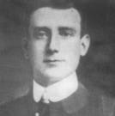

George Clancy
Member of Limerick City Council from 1920-1921
(Courtesy of Limerick City Archives)

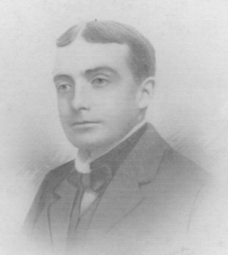

Michael O’Callaghan
Member of Limerick City Council from 1911-1921
(Courtesy of Limerick City Museum)

Limerick City Municipal Election Results
June 1925

Abbey and Castle Wards

Aldermen: Patrick (Paddy) Donnellan IND; John Ryan LAB.
Councillors: Michael P. Colivet REP; Patrick J. Cusack IND; Patrick Doyle REP;
Joshua Fitzelle IND; Christopher Gilligan REP; Alfred E. Goodwin PRO;
John McNamara IND; Patrick Moore IND; James (Mossie) Reidy IND.

Custom House and Market Wards

Alderman: Joseph McInerney LAB.
Councillors: Patrick Bourke IND; Michael (Mick) Keyes LAB;
Thomas McNamara REP; John G. O’Brien PRO; John O’Halloran IND;
Eric R. Shaw PRO.

Dock Ward
Aldermen: Robert W. (Bob) de Courcy REP; Patrick O’Flynn IND.
Councillors: James Casey LAB; John Cronin LAB; Michael Gough PRO;
John Hall IND; Paul A. O’Brien PRO; Hugh L. Place PRO.

Glentworth and Shannon Wards

Aldermen: Daniel (Dan) Bourke REP; Patrick J. Henehan IND.
Councillors: Patrick O’Callaghan REP; John Cronin LAB; William Hickey PRO;
Maurice S. Powers PRO; Matthew Quillinan PRO; Patrick Walsh LAB.

Irishtown Ward
Alderman: Joseph Thompson IND.
Councillors: Martin Barry REP; John Canty LAB; John Dalton IND; Daniel Flynn LAB;
John White IND.

* First municipal election held under the new Irish Free State.
* PRO: Progressive Party, a movement of the 1920s, ’30s and ‘40s closely associated
with Cumann na nGaedhael (later Fine Gael).

Limerick City Municipal Election Results
June 1928

Abbey and Castle Wards

Aldermen: James (Mossie) Reidy; Patrick (Paddy) Donnellan.
Councillors: Thomas Cleary; Patrick J. Cusack LAB; Patrick Doyle;
Christopher Gilligan; Alfred E. Goodwin; Edward T. Halvey;
John McNamara; Patrick Moore; Joseph O’Brien.

Custom House and Market Wards

Alderman: Joseph McInerney.
Councillors: James Angley; Patrick Bourke; Michael (Mick) Keyes LAB;
Thomas McNamara; John G. O’Brien; Eric R. Shaw.

Dock Ward

Aldermen: Dr. Fogerty; Patrick O’Flynn IND.
Councillors: Michael Brouder; Patrick Carmody; James Casey;
Robert W. (Bob) de Courcy; Paul A. O’Brien; Hugh L. Place.

Glentworth and Shannon Wards

Aldermen : Daniel (Dan) Bourke TD; Thomas J. Wallace.
Councillors: Patrick O’Callaghan; John Cronin; Michael Daly; Patrick J. Henihan;
Charles V. O’Malley; Matthew Quillinan.

Irishtown Ward

Alderman: John Canty INDL.
Councillors: Martin Barry FF; John Dalton IND; William Ford FF; John C. Hickey IND;
P. Madigan LAB.

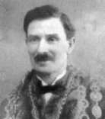

Michael Keyes
Member of Limerick City Council from 1920-1949
(Courtesy of Limerick City Archives)

Limerick City Municipal Election Results
June 1931

Abbey and Castle Wards

Aldermen: Patrick J. (Paddy) Donnellan PRO; James (Mossie) Reidy PRO.
Councillors: Michael Bowles IND; Daniel Clancy LAB; Patrick J. Cusack LAB;
Patrick Doyle IND; Christopher Gilligan IND; Alfred E. Goodwin PRO;
John McNamara PRO; Patrick Moore PRO; Joseph O’Brien FF.

Custom House and Market Wards

Alderman: Joseph McInerney IND.
Councillors: James Angley FF; Patrick Bourke PRO; Michael Keyes LAB;
Thomas McNamara FF; Patrick F. Quinlan PRO; M. Rooney IND.

Dock Ward

Aldermen: Michael Brouder LAB; Patrick O’Flynn IND.
Councillors: James Casey IND; Robert W. (Bob) de Courcy FF;
Thomas Gough PRO; Patrick Horrigan LAB; C. O’Connor PRO;
J.P. O’Sullivan PRO.

Glentworth and Shannon Wards

Aldermen: Daniel (Dan) Bourke TD FF; Thomas J. Wallace PRO.
Councillors: J. Barrett IND; John Cronin LAB; Michael Daly FF; H. Ferguson
LAB; William Hickey PRO; Charles V. O’Malley PRO.

Irishtown Ward

Alderman: P. Madigan LAB.
Councillors: John Dalton PRO; John Canty IND; John C. Hickey IND;
Stephen Hickey FF; Matthew J. Quilligan PRO.

* This was the tenth council to be elected under the Local Government Act 1898
and the fourth under the 1919 Local Government Act (Ireland) Proportional
Representation.
Limerick City Management Act 1934

The Limerick City Management Act 1934 substantially altered the basis of local government in Limerick City. Besides the creation of the office of City Manager, a professional overseer of the city’s public business, the Act radically altered the elective body on whose behalf the Manager conducts the city’s affairs. From a forty member body elected from several electoral wards, the city council became a fifteen member body (of whom four were aldermen) elected from one electoral unit. Under the 1934 Management Act, the Limerick County Borough Board of Health was abolished and its properties and functions transferred to the Corporation. The committee of management appointed by the Council of the County Borough of Limerick under the Tuberculosis Prevention Acts of 1908 and 1913 and the gas committee appointed under the Limerick Corporation Gas Act, 1878 were also abolished and their functions, powers and duties were transferred to the Corporation.

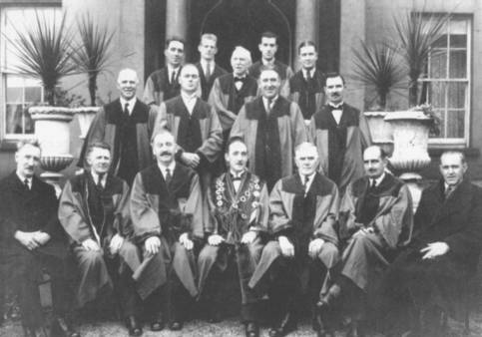

The first City Council elected under the Limerick City Management Act of 1934.

Front row: Cllr J. Dalton; Alderman J. Reidy TD; Alderman D. Bourke TD;
Cllr J.M. Casey (Mayor); Alderman J. McInerney; Alderman A.E. Goodwin;
J.P. Geraghty, City Manager. Second row: Cllr P.F. Quinlan;
Cllr P. Donnellan; Cllr M. Hartney; Cllr M.J. Keyes TD. Back row:
Cllr M. Daly; Cllr P.F. Shanny; Cllr P. Bourke; Cllr J.C. Hickey;
Cllr D.J. O’Malley.
(Courtesy of Egleston Brothers)

Limerick City Municipal Elections Results
November 1934

Aldermen: Daniel (Dan) Bourke TD FF; Alfred E. Goodwin PRO;
Joseph McInerney IND; James (Mossie) Reidy TD PRO.

Councillors: P. Bourke PRO; James Casey LAB; John Dalton PRO; Michael Daly FF;
Patrick J. (Paddy) Donnellan PRO; Michael Hartney FF;
John C. Hickey FF; Michael J. (Mick) Keyes TD LAB;
Desmond J. O’Malley FF; Patrick F. Quinlan PRO; P.F. Shanny FF.

* The 1934 election was the first conducted under the Limerick City Management
Act.

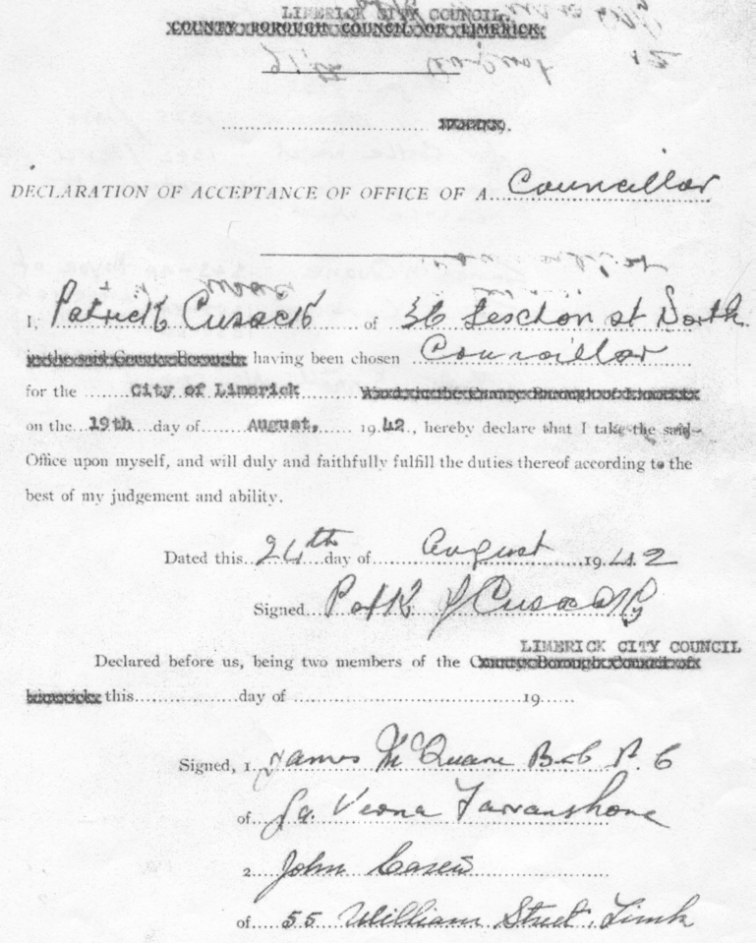

Declaration of acceptance of office as councillor from Patrick Cussack

Limerick City Municipal Election Results
August 1942.

Aldermen: Daniel (Dan) Bourke TD FF; John Carew PRO;
Desmond J. O’Malley FF; James (Mossie) Reidy PRO.

Councillors: James Casey LAB; Patrick J. Cusack LAB;
Patrick J. (Paddy) Donnellan IND; Michael Hartney FF;
John C. Hickey FF; Michael J. (Mick) Keyes TD LAB;
Martin W. McGuire IND; James McQuane LAB;
Charles V. O’Malley PRO; Daniel Reddan IND;
George E. (Ted) Russell IND.

* Under the Local Government Extended Franchise Act 1935 all citizens over 21
years old and not subject to any legal incapacity were granted a vote in elections.
The number of persons qualified to vote at the municipal elections had jumped
from 12,806 in 1934 to 23,693 in the 1942 election.

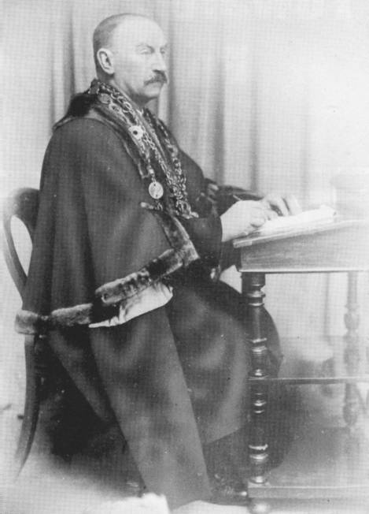

Dan Bourke
Member of Limerick City Council from 1920-1952

Limerick City Municipal Election Results
June 1945

Aldermen: Daniel (Dan) Bourke TD FF; John Carew PRO; Michael Hartney FF;
James (Mossie) Reidy TD PRO.

Councillors: John Connery FF; Patrick J. Cusack INDL; Gerald B. Dillon FF;
Patrick J. (Paddy) Donnellan IND; John C. Hickey FF;
Michael J. (Mick) Keyes TD LAB; Martin W. McGuire GL;
Patrick O’Connell FF; Michael B. O’Malley FF;
George E. (Ted) Russell GL; Patrick Whelan IND.

* An increase in polling stations was provided during this election due to the fact
that polling was taking place for President on the same day.
* GL: Gluais Linn meaning ‘Forward/Come/Advance With Us’.
City of Limerick (Extension of Boundary) Provisional Order 1950.

On 11 January 1950 the Minister for Local Government and ex-mayor of Limerick, Micheal Keyes signed the City of Limerick (Extension of Boundary) Provisional Order which became law on 1 April 1950. Limerick City’s territorial area was now increased by 2,395 acres to a total of 5,155 acres. The purpose of the boundary extension was to facilitate the Corporation in moving forward with its housing programme and eradicating the city slums that existed. As a result of the boundary extension the membership of the city council was increased from fifteen to seventeen under the provisions of the second Limerick City Management Act, which became law on the 26 July 1950.

Limerick City Municipal Election Results
September 1950

Aldermen: Daniel (Dan) Bourke FF; John Carew FG; James (Mossie) Reidy FG;
George E. (Ted) Russell CnaP.

Councillors: Kevin Bradshaw FF; John Connery IND; Stephen (Stevie) Coughlan CnaP;
John Cunneen FF; Gerard B. Dillon, Mayor FF;
Patrick J. (Paddy) Donnellan IND; John Finnan FF; Frank Glasgow FF;
Christopher (Christy) Keyes LAB; Patrick O’Connell FF;
Michael B. O’Malley FF; Kevin O’Sullivan IND; Sean Walsh FG.

* First municipal election held under the City of Limerick (Extension of Boundary)
Provisional Order 1950.
Limerick City Municipal Election Results
June 1955

Aldermen: John Carew TD FG; Stephen (Stevie) Coughlan CnaP;
Donogh B. O’Malley TD FF; George E. (Ted) Russell CnaP.

Councillors: William Brazier FF; Joseph Carr FF; John (Jack) Danagher CnaP;
Gerald B. Dillon FF; Patrick J. (Paddy) Donnellan RP;
Frank Glasgow FF; Patrick (Paddy) Kelly FG;
Christopher (Christy) Keyes LAB; Joseph P. (Rory) Liddy FF;
Patrick Mulcahy SF; Patrick O’Connell FF; James (Mossie) Reidy Sen. FG;
Frank Wallace RP.

Limerick City Municipal Election Results
June 1960

Aldermen: John Carew FG; Stephen (Stevie) Coughlan CnaP;
Donogh B. O’Malley FF; George E. (Ted) Russell FG.

Councillors: William Brazier FF; Frances Condell (née Eades) IND-Ratepayers
Association; Thomas Creamer FF; John (Jack) Danagher CnaP;
Gerard B. Dillon FF; Frank Glasgow FF; John Keane FF;
Patrick (Paddy) Kelly ITGWU; Frank Leddin LAB;
Joseph P. (Rory) Liddy FF; Michael (Mick) Lipper CnaP;
Patrick O’Sullivan INDL; James (Mossie) Reidy FG.

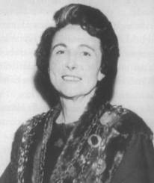

Frances Condell
Member of Limerick City Council from 1960-1967
(Courtesy of Limerick City Archives)

Limerick City Municipal Election Results
June 1967

Ward One

Alderman: George E. (Ted) Russell FG.
Councillors: John A. (Tony) Bromell FF; Michael Earls LAB; Sean Fielding FF.

Ward Two

Alderman: Michael (Mick) Lipper LAB.
Councillors: Vincent Feeney FF; Patrick G. (Paddy) Kiely FF;
Denis A. (Gus) O’Driscoll FG; Joe Quinn IND.

Ward Three

Alderman: Stephen (Stevie) Coughlan LAB.
Councillors: John (Jack) Bourke FF; Frank Glasgow FF; Frank Leddin LAB.

Ward Four

Alderman: Patrick (Pat) Kennedy FG.
Councillors: John Carew FG; Clement (Clem) Casey FF; Joseph P. (Rory) Liddy FF.

* In 1967 in accordance with the Electoral Act, 1963 Limerick City was divided
into new electoral wards. Ward One (four elected members); Ward Two (five
elected members); Ward Three (four elected members); Ward Four (four
elected members) - to include one alderman in each ward. The ward system
had last been used in the 1931 municipal election.
Limerick City Municipal Election Results
June 1974

Ward One

Alderman: George E. (Ted) Russell FG.
Councillors: John A. (Tony) Brommell FF; Michael (Mick) Crowe IND;
Francis J. (Frank) Prendergast LAB.

Ward Two

Alderman: Michael (Mick) Lipper LAB.
Councillors: Jim Kemmy NP; Patrick G. (Paddy) Kiely FF;
Denis A. (Gus) O’Driscoll FG; Desmond J. (Dessie) O’Malley FF.

Ward Three

Alderman: Stephen (Stevie) Coughlan LAB
Councillors: John (Jack) Bourke FF; Denis Broderick FG; Frank Leddin LAB.

Ward Four

Alderman: Patrick (Pat) Kennedy FG.
Councillors: Patrick R. (Bobby) Byrne FG; Clement (Clem) Casey FF;
Thady Coughlan LAB.

* The Electoral (Amendment Act) 1973 lowered the voting age from 21 to 18.

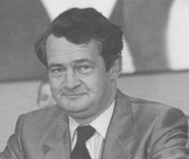

Desmond J. O’Malley
Member of Limerick City Council from 1974-1977

Limerick City Municipal Election Results
June 1979

Ward One

Alderman: Francis J. (Frank) Prendergast LAB.
Councillors: John A. (Tony) Bromell FF; John Quinn FF; George E. (Ted) Russell FG.

Ward Two

Alderman: Jim Kemmy INDS.
Councillors: Denis A. (Gus) O’Driscoll FG; Patrick G. (Paddy) Kiley FF;
Michael (Mick) Lipper LAB; Patrick (Paddy) Madden FF.

Ward Three

Alderman: Thomas Allen LAB.
Councillors: John (Jack) Bourke FF; Therese (Terry) Kelly (nee Barry) FG;
Frank Leddin LAB.

Ward Four

Alderman: Patrick (Pat) Kennedy FG.
Councillors: Patrick R. (Bobby) Byrne FG; Clement (Clem) Casey FF;
Win Harrington IND.
.

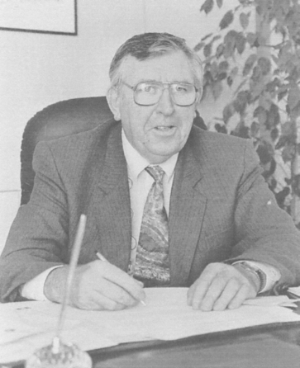

Jim Kemmy
Member of Limerick City Council from 1974-1997
(Courtesy of Limerick City Museum)

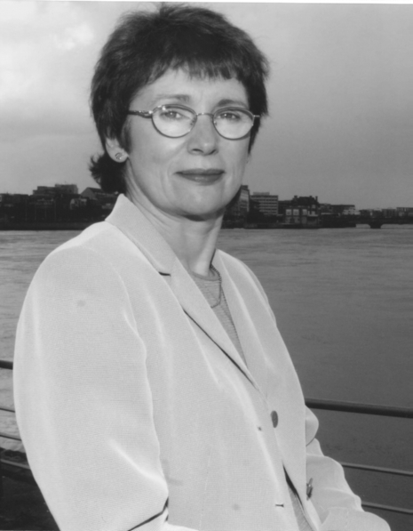

Janice O’Sullivan
Member of Limerick City Council from 1985-2003

Limerick City Municipal Election Results
June 1985

Ward One

Alderman: Tim Leddin FG.
Councillors: Tim O’Driscoll DSP; Francis J. (Frank) Prendergast LAB; John Quinn FF.

Ward Two

Alderman: Denis A. (Gus) O’Driscoll FG.
Councillors: Larry Cross FF; Kevin Kiely FG; Patrick (Paddy) Madden FF;
Janice (Jan) O’Sullivan (née Gale) DSP.

Ward Three

Alderman: Jim Kemmy DSP.
Councillors: John (Jack) Bourke FF; Ger Fahy FG; James J. (Joe) Harrington PDEM.

Ward Four

Alderman: Patrick (Pat) Kennedy FG.
Councillors: Patrick R. (Bobby) Byrne FG; John O’Connor FF; Win Harrington NP.

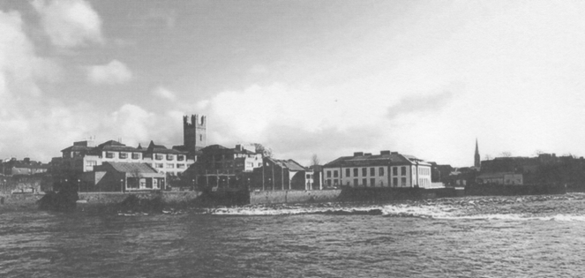

Limerick City Hall officially opened 1 June 1990
(Courtesy of Dehur’s Photostream)

Limerick City Municipal Election Results
June 1991

Ward One

Alderman: Willie O’Dea FF.
Councillors: Tim Leddin FG; Francis J. (Frank) Prendergast LAB; John Quinn PD.

Ward Two

Alderman: John Gilligan IND.
Councillors: Denis A. (Gus) O’Driscoll FG; Kieran O’Hanlon PD;
Janice (Jan) O’Sullivan (née Gale) LAB; John Ryan WP.

Ward Three

Alderman: Jim Kemmy LAB.
Councillors: John (Jack) Bourke FF; James J. (Joe) Harrington IND; Frank Leddin LAB.

Ward Four

Alderman: Sean Griffin LAB.
Councillors: Patrick R. (Bobby) Byrne FG; Patrick (Pat) Kennedy FG;
Richard A. (Dick) Sadlier PD.

Twentieth Amendment of the Constitution Act 1999

Since as far back as when the City Management Act of 1934 came into effect local elections were being held sporadically. With constant delays in holding elections the Local Elections Act of 1953 was brought into legislation specifying that the normal period of a local council should be five years and not the three year period stated in the Local Government Act of 1898. Local elections were held in 1955 and 1960 but thereafter the same irregular pattern fell into practice. To put an end to this, on 23 June 1999 Article 28A3 was added to the Irish Constitution which stated that:

‘Elections for members of such local authorities shall be held in accordance with law not later than the end of the fifth year after the year in which they were last held’

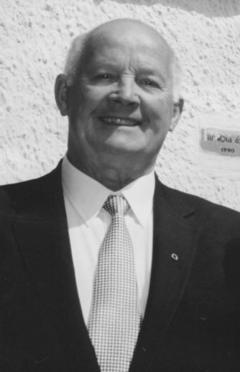

Frank Prendergast
Member of Limerick City Council from 1974-1999

Limerick City Municipal Election Results
June 1999

Ward One

Alderman: Peter Power FF.
Councillors: John Cronin FF; Michael Hourigan FG; Kathleen Leddin (née Keyes) IND.

Ward Two

Alderman: Janice (Jan) O’Sullivan (née Gale) LAB.
Councillors: Larry Cross FF; John Gilligan IND; Kieran O’Hanlon FF; John Ryan LAB.

Ward Three

Alderman: Michael Kelly IND.
Councillors: John (Jack) Bourke FF; Ger Fahy FG; Diarmuid Scully FG.

Ward Four

Alderman: Patrick (Pat) Kennedy FG.
Councillors: Maria Byrne FG; Joe Leddin LAB; Richard A. (Dick) Sadlier FF.

Local Government Act 2001

The Local Government Act 2001, which came into effect in January 2002, provided for a ‘County Borough’ to be referred to as a ‘City’ and for a ‘County Borough Corporation’ to be referred to as a ‘City Council’. At the same time all Town Commissions and Urban District Councils became known as ‘Town Councils’. There were no changes in administrative structure or function as a result of these name changes.

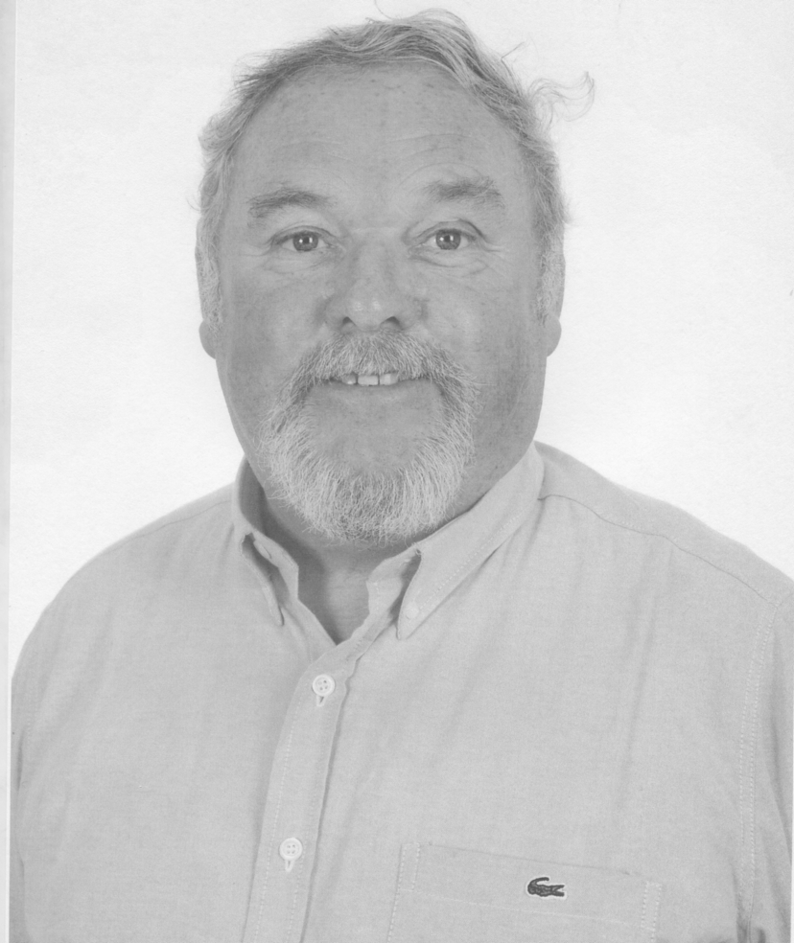

John Gilligan
Member of Limerick City Council from 1991 till present
(Courtesy of Sean Curtin)

Limerick City Municipal Election Results
June 2004

Ward One

Councillors: John Cronin FF; Michael Hourigan FG; Kevin Kiely FG;
Kathleen Leddin (née Keyes) NP; John Ryan LAB.

Ward Two

Councillors: John Gilligan NP; Gerry McLoughlin NP; Kieran O’Hanlon FF;
Kieran Walsh LAB.

Ward Three

Councillors: Ger Fahy FG; James Houlihan LAB; Diarmuid Scully FG;
Lily Wallace NP.

Ward Four

Councillors: Maria Byrne FG; Patrick (Pat) Kennedy NP; Joe Leddin LAB;
Jim Long NP.

* In May 2004 the last alderman recorded in the Limerick City Council Minute
Book was Alderman Patrick Kennedy. Thereafter the title of alderman was
abolished.
Limerick City Boundary Alteration Order 2008

In September 2007 the Minister for the Environment, Heritage and Local Government, John Gormley announced the establishment of a Boundary Committee to examine an extension of Limerick City’s boundary. In a report, ‘Addressing Issues of Social Exclusion in Moyross and Other Disadvantaged Areas of the City’, prepared by John Fitzgerald and adopted by the government in April 2007, one recommendation made was an extension of Limerick City Council’s boundary in the northern part of the city to facilitate intensive development and regeneration.

On 1 March 2008 the Limerick City Boundary Alteration Order 2008 became effective transferring Limerick North Rural electoral division (population 7,251) from Limerick County to Limerick City and encompassing the suburb of Carherdavin and the regeneration area of Moyross. The boundary extension area of 1020 hectares (less than 0.5% of the area of the county) comprised of the townlands of Ballygrennan; Clonconane; Clondrinagh; Clonmacken; Caherdavin; Coonagh East; Coonagh West; Knock and Shanabooley.

The Boundary Committee recommended merging two of the existing electoral areas in the city thereby reducing the number of electoral areas from four to three. The areas were renamed Limerick City North (previously Ward One), Limerick City East (previously Ward Two) and Limerick City South (previously Wards Three and Four). As a result of the extension of the boundary of the city, and an increase in the population of Ward One (City North), the number of city council members for that ward was increased from five to six. There was no change to the boundary or number of city councillors (four) in City East (Ward Two). The merged electoral areas Wards Three and Four (City South) were assigned seven city council members.

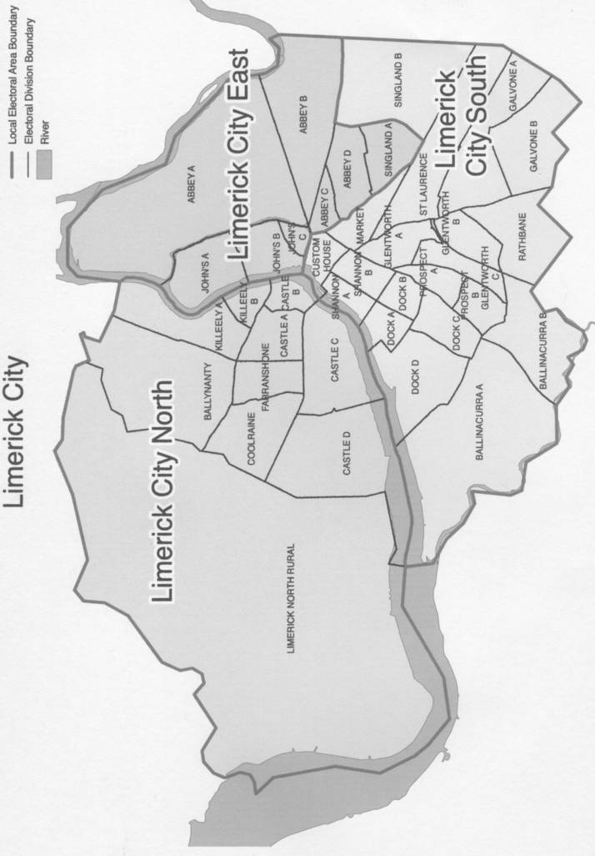
Limerick City Electoral Boundaries 2009
Limerick City Municipal Election Results
June 2009

City East

Councillors: John Gilligan NP; Denis McCarthy FG; Gerry McLoughlin LAB;
Kieran O’Hanlon FF.

City North

Councillors: Michael Hourigan FG; Cormac Hurley FG; Kevin Kiely FG;
Kathleen Leddin (née Keyes) NP; Maurice Quinlivan SF; Tom Shortt LAB.

City South

Councillors: Maria Byrne FG; Ger Fahy FG; Patrick (Pat) Kennedy IND;
Joe Leddin LAB; Jim Long FG; Orla McLaughlin LAB;
Diarmuid Scully FG.

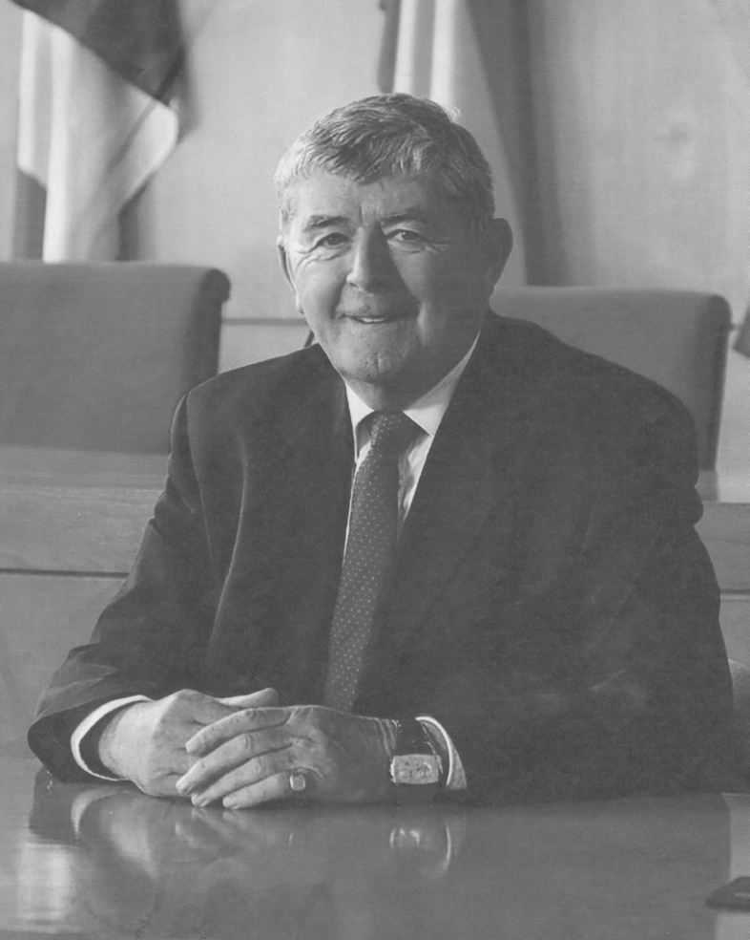

Michael Hourigan
Member of Limerick City Council from 1999 till present

Limerick Corporation 1841-2009

Sources of Information

Bassett’s Directory
Limerick City Library
1875 1880

Guys Directory
Limerick City Library
1886

Limerick Chronicle
Limerick City Library
1842 1845
1843 1899
1844 1928

Limerick City and County Directory
Limerick City Library
1890

Limerick Corporation Minute Book
Limerick City Archive
1844 1845 1849

Limerick Leader
Limerick City Library
1902 1934 1955 1991
1905 1942 1960 1999
1908 1945 1967 2004
1911 1950 1985 2009

The Irish Times
Irish Times Archives
1974 1979

Thoms Directory
Cork City Library
1846 1882
1850 1891
1873 1894

Ennis Library
1847
1863
1865

Fingal Library
1844 1872 1889 1897
1855 1877 1892 1898
1857 1885 1893
1866 1887 1895

Limerick County Library
1874 1884

National Library, Dublin
1848 1854 1860 1867 1871 1883
1851 1856 1861 1868 1876 1888
1852 1858 1862 1869 1878
1853 1859 1864 1870 1879

Tallagh Library
1881 1896

Potter, Matthew The Government and the People of Limerick. The History of Limerick Corporation/City Council 1197-2006, Limerick City Council, 2006.
Son of Pierce Shannon who died in 1844.
Potter, Matthew The Government and the People of Limerick. The History of Limerick Corporation/City Council 1197-2006, Limerick City Council, 2006.
Limerick Leader, 1 August 1942.
City of Limerick (Extension of Boundary) Provisional Order 1950.
Potter, Matthew The Government and People of Limerick; The History of Limerick Corporation/Cit y Council 1197-2006, Limerick City Council, 2006, p.432.
Limerick City Management Act 1950.
Potter, Matthew The Government and People of Limerick. The History of Limerick Corporation/City Council1197-2006, Limerick City Council, 2006, pp. 458-59.
Constitution of Ireland-Bunreacht Na hÉireann.
2006 Census.
Limerick City Council website www.limerickcity.ie

